Construction of The E-Government -Case Study of Japan and Estonia-
Nozomi Tomura ^{1,*}, Saki Uehara ², Konosuke Kaneta ³, Ryosuke Hara ⁴, Ryogo Sasaki ⁵, Maho Tsuchida ⁶, Ayu Shibuya ⁷, Maiko Yamashita ⁸
Chuo University 742-1 Higashinakano, Hachioji, Tokyo, Japan
chuouflp2017@gmail.com *
* corresponding author

(Received July 4, 2021 Revised July 22, 2021 Accepted August 20, 2021, Available online September 1, 2021)
Abstract
The internet and PCs have been spreading in the world since the 1990s. The usage of these technologies not only in the business field but also in ordinary society. One of those business styles is Electronic Commerce. Most of the governments of countries and economists are taking these information technologies into their policies and developing them as their own IT policy. Above all, This paper summarized the history, structure, concrete outcomes and future plans for ICT, which is being advanced in Estonia, many of the ICT society including Japan is eager to realize, and introduces items that should be adopted to Japan.

Keywords: Internet; Technology; E-Commerce; IT; ICT; E-Government;

Introduction
Japan has lost its brightness since the collapse of the bubble in the early 1990s. A business model that lasted more than 40 years after the war, that is, incorporates advanced technologies in Europe and the United States, producing products such as steel, automobiles, and electric appliances at a higher quality and at a lower price compared to such developed countries and exporting it. It has succeeded and has been a major driving force in Japan's economic growth. However, now countries such as South Korea and Southeast Asia, which have lower labor costs than Japan, have followed the Japanese business model to rapidly develop their countries. On the other hand, due to the economic downturn, Japan cannot find a new business model.
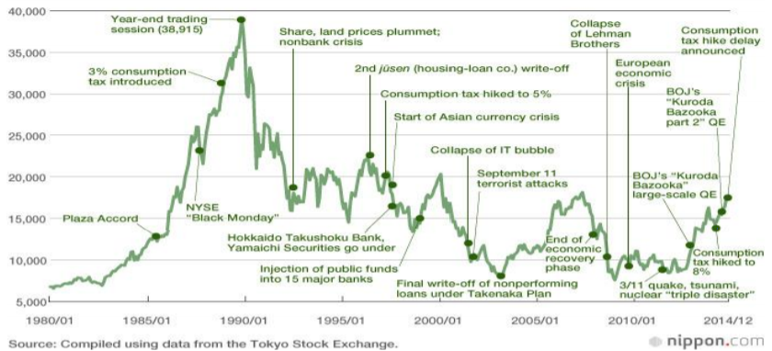
Figure. 1. Historical Nikkei average
In addition, since 1990 when the bubble collapsed, the era of political long-term confusion and stagnation continued, such as the prime minister's change by 15 times in about 25 years. Even if it tried to take that economic measure, due to the influence of the political constitution that relies on the old fashioned public works remain, the debt outstanding in Japan finally exceeded 1,000 trillion yen. Many citizens are strengthening the sense of crisis, expecting to improve administrative efficiency and improve transparency.

Literature Review
For the past twenty years, the Japanese government has not thought about increasing efficiency administration and they do nothing. However, there is no visible result on the action taken. The Japanese government launched the "e-Japan Strategy" in 2001 and has been promoting development of information communication infrastructure and development of applications such as e-government, with the aim of becoming the most advanced information and communication in the world technology country within five years. Since 2006, we have launched a new ICT reform Strategy, and from 2010, they develop an environment for countries where all citizens can enjoy the benefits of ICT. Meanwhile, there are also results such as the establishment of an environment where many citizens can using broadband Internet at low prices. However, the "e-government" service, which is administrative services via the internet to citizens, have not been used properly. In particular, the deployment of "Basic Resident Ledger" and "Public Personally Certified" which is the basis of personal identification and electronic signatures required to provide many service requests will not be processed on a dead end; the government could not find a breakthrough. To summarize the situation, the policy for "e-government construction" includes the e-Japan strategy far from successful.

Methodology

Figure. 2. About Estonia
We can raise one country that should be referred to solve these serious problems. That is “Estonia”. Estonia is one of the Baltic States, a country independent of the Soviet Union in 1991. Bordering Latvia, and Russia, facing the Baltic Sea and the Finnish Gulf. Although the area of the country is 45,000 square meters, which is about one-ninth compared to Japan, and the population is a small country of about 1.34 million people, steady economic growth has been achieved by the tourism economy and the IT industry. What is noteworthy in this country is that well known for an advanced ICT country and is doing advanced efforts in the field of e-government for these reasons, more than 1000 inspection groups visit the country annually and attract attention from many countries.
For example, in Estonia, most of the citizens has a national ID card that proves they are Estonian citizens. In October 2005, it was the first time in the world to conduct regional elections via the Internet; moreover, in March 2007 it allowed Internet voting in national elections. Considering that the start of the Japanese individual number as nicknamed” My Number” system in January 2016, it seems that Japan is more than 10 years behind compared to Estonia in the field of egovernment. Surprisingly, despite these large-scale efforts, the national budget for Estonia's ICT construction is around 7 billion yen a year, despite investment less than 1% compared to Japan's budget; it is far ahead of Japan in using e-Government.
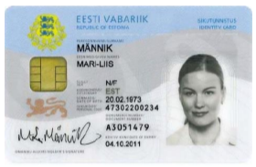
Figure. 3. Estonia’s e-ID card

3.1. Examples of Estonia’s Initiatives

3.1.1. Medical policy
Since 2008, electronic medical management services in Estonia has begun. The medical system of Estonia, like Japan and Taiwan, is a public health insurance. Their companies pay premiums for the employee; on the other hand, each person pays for those who are not. Estonia has no individual health insurance card. Otherwise, if you bring an ID card, you can check whether you become a member of health insurance or not, and if you are in health insurance, you can receive medical treatment at any hospital in Estonia for free.
In Estonia, medical information can already be shared, and electronic medical record, electronic image storage and access, online reservation, electronic prescription system are presently used. For these reasons, for instance, due to the medical history of citizens is stored electronically, even when going to a hospital suddenly suffering from a traveling, the local doctor can check the medical history of the patient and make a diagnosis.
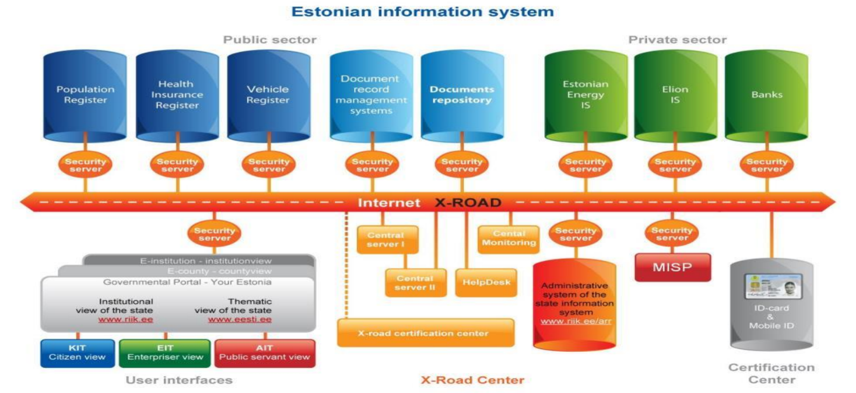
Figure. 4. Estonian information system

3.1.2. Administrative Efficiency
Within a few exceptions, under the policy of “paperless Estonia”, the Estonian government worked on the introduction of electronic records management through all ministries and agencies. Materials are uploaded to the server by the day before and the Cabinet meeting and stakeholders can participate in the cabinet meeting after checking in advance. Even outside of the country, you can participate in the meeting via the internet. The Minister reads drafts and rules, makes comments and suggestions, and votes by electronic signature at the computer terminal. The minutes of the meeting will be posted on the Web to the public on the following day.
Because of the use of the electronic Cabinet meeting, after the paperless Cabinet meeting, the cost of copying paper has been reduced by EUR 190,000 per year, and the conference time has been sharply reduced.

3.1.3. Participatory portal site
To tell the people's will to the government, a new e-participation called “Osale” started in 2007 and a participatory portal for e-democracy was established. The purpose of this participatory portal is to allow stakeholders such as companies, Estonian residents, civil society organizations to obtain information on public matters and make calls. Participants can post opinions to the draft legislation prepared by the government through this portal site. Expression of opinions by various stakeholders has the effect of making the decision more transparent and more open, increasing the quality of decision, policy, legislation and social justification.

Figure. 5. Cityscape of Estonia

3.1.4. Shape of new education
“E – Kool” is a connection between all teachers, students, and guardian. Have a consistent policy on student learning and growth and support improvement of communication among different stakeholders. It also makes parents more actively participate in school life and its curriculum, makes school information more accessible to them, reduces the amount of regular work of schools and teachers, makes reporting and analysis easier, Improve the administrative capacity of school. The teacher fills in the contact information to the guardian via this system, and the guardian can check the contents at any time by using a personal computer or mobile phone. With this system, teachers can communicate directly with their students grade assessment, teaching contents, cancel their classes, homework to the parents.

Results and Discussion

Solution

Acquisition of public understanding
To establish the ICT promotion plan, basic consensus is needed among the people. To that end, policy consistency and disclosure of information are necessary. For example, the introduction of the “My Number” system is currently undergoing rapid progress in Japan, but we should actively disclose information on what kind of system the My Number will be used in the future. If we cannot explain such things as tax and social security first, it is difficult to obtain consensus of the people. In Estonia, they have published the interim plan and annual progress as an annual and published it on the web site. This enables the public to know the plan, budget and progress of ICT promotion. In addition, related laws are listed on the web and can be easily learned. The ICT promotion strategy in Japan is as follows, but it is not easy to find the progress report, not on the web of IT strategy headquarters. In addition, the ICT law is also important, and an easy-to-understand explanation is also necessary. Figure 6 transition of Japanese IT strategy.
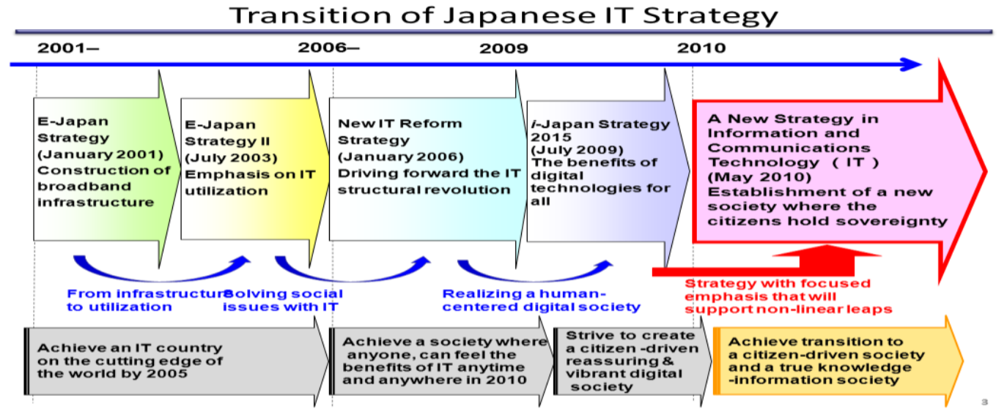
Figure. 6. Transition of Japanese IT strategy

Improvement of usage environment
Instead of using multiple certificates, such as a health insurance certificate, a car license, a pension notebook, etc., you should aim for an e-ID card that can be shared by one sheet. In addition, functions that can be used with mobile phones and smartphones that are compatible with the “mobile era” are required. Efforts to increase the available environment are also necessary. Rather than thinking on the premise that the user uses from a personal computer or a smartphone at home, it is necessary to put a public terminal and an explanatory person at least in a public facility.

Diffusion strategy
“My number” card and electronic administrative service need "policy to be used". For mere electronic administrative services, it will be used several times a year. In order to prevent such a situation, first of all, it is necessary to consider services that have merit as a citizen and raise their priorities. As an example, I will take up the "passport electronic application system" once adopted by the Ministry of Foreign Affairs in Japan. This was only used in 133 cases in 3 years of introduction and was abolished in 2005.
Two issues are raised about this. First of all, it is a question that "It was too emphasized that only 133 cases were used in the introduction of three years“. If the applicants can apply for a passport from the Internet, the benefits for the people should be large. This system has been abolished without the adequate explanation of the merit of electronic issuance that approximately 3.2 million passport issuance applications are currently issued. The second is the appropriateness of its development expenses. When dividing the system construction cost of 2 billion yen or more by the number of issued passports, it became a big problem that became about 16 million yen per case, no explanation that “why did such a huge cost be taken” was not sufficiently done. In both cases, the fact that the viewpoint of the user is lacking is the biggest problem.

Thinking on cost
In Estonia, they were thinking about using international standards from the start point of system construction and utilizing open source, so they could achieve lower development cost. Likewise, if Japan can shift to a policy of using existing ones already, not limiting them to those developed by domestic enterprises, development costs can be reduced.

Conclusion
Japan has already begun activities to become an ICT advanced nation in the world through the eJapan strategy that began in 2001 and the subsequent ICT new reform strategy, already 15 years have passed. Initially it was expected that many e-government services will be used nationwide in 2005, but even now in 2017, except for some industries, it can be said that the current situation is not different from that of 16 years ago. From that reflection, the government is delaying the introduction of the National ID number (My Number). This will enable back office collaboration and reduce the burden on users. However, what kind of services are specifically provided and how the burden on residents is reduced is not provided in an easy-to-understand manner. The Republic of Estonia introduced in this paper, since independence in 1991, has been developing a digital society carefully using a lot of time and wisdom, although it is a small country with a small history. Thus, it became one of ICT developed countries. When promoting things, they have studied not only technology but also law, structure, budget at the same time. In this opportunity, it is important to refer to how to proceed Estonia's digital society. In Estonia, in 1998, they adopted the basic policy of promoting ICT "Estonian Information Policy Principles" in 1998, and along with this, they are making progress plans to build a digital society by making promotion plans every seven years. In Japan, it is necessary to prepare the same "basic policy of promotion of ICT", clarify the purpose of ICT promotion, policy to promote public-private partnership, A government that does not try to advance anything by reason is impossible for the people. In the current situation where Japan's government and electronic administration have been delayed so far, Japanese government should abandon boring prides and excuses and learn much from the preceding country like the “Meiji Restoration”.

References
- F. Bélanger and L. Carter, “The effects of the digital divide on E-government: An empirical evaluation,” Proc. Annu. Hawaii Int. Conf. Syst. Sci., vol. 4, 2006, doi: 10.1109/HICSS.2006.464.
- E. Abu-Shanab, “Antecedents of trust in e-government services: An empirical test in Jordan,” Transform. Gov. People, Process Policy, vol. 8, no. 4, pp. 480–499, 2014, doi: 10.1108/TG-08-2013-0027.
- Z. Li and F. Yang, “The E-government Information Model Based on GPR,” Procedia Comput. Sci., vol. 91, pp. 193–200, 2016, doi: 10.1016/j.procs.2016.07.057.
- A. Adadi, E-GOVERNMENT Global e- government theory , applications and benchmarking. IDEA GROUP PUBLISHING.
- C. A. Hardy and S. P. Williams, “E-government policy and practice: A theoretical and empirical exploration of public e-procurement,” Gov. Inf. Q., vol. 25, no. 2, pp. 155–180, 2008, doi: 10.1016/j.giq.2007.02.003.
- Z. Ebrahim and Z. Irani, “E-government adoption: Architecture and barriers,” Bus. Process Manag. J., vol. 11, no. 5, pp. 589–611, 2005, doi: 10.1108/14637150510619902.
- M.-S. Hwang, C.-T. Li, J.-J. Shen, and Y.-P. Chu, “Challenges in E-Government and Security of Information,” Inf. Secur. An Int. J., vol. 15, no. 1, pp. 9–20, 2004, doi: 10.11610/isij.1501.
- P. G. Nixon and V. N. Koutrakou, “E-government in Europe: Re-booting the state,” E-Government Eur. Re-Booting State, pp. 1–220, 2006, doi: 10.4324/9780203962381.
- X. Papadomichelaki and G. Mentzas, “E-GovQual: A multiple-item scale for assessing e-government service quality,” Gov. Inf. Q., vol. 29, no. 1, pp. 98–109, 2012, doi: 10.1016/j.giq.2011.08.011.
- X. Papadomichelaki and G. Mentzas, “A multiple-item scale for assessing e-government service quality,” Lect. Notes Comput. Sci. (including Subser. Lect. Notes Artif. Intell. Lect. Notes Bioinformatics), vol. 5693 LNCS, pp. 163–175, 2009, doi: 10.1007/978-3-642-03516-6_14.
- P. Papadopoulou, M. Nikolaidou, and D. Martakos, “What is trust in e-government? A proposed typology,” Proc. Annu. Hawaii Int. Conf. Syst. Sci., no. January 2014, 2010, doi: 10.1109/HICSS.2010.491.
- B. Azad and S. Faraj, “E-Government institutionalizing practices of a land registration mapping system,” Gov. Inf. Q., vol. 26, no. 1, pp. 5–14, 2009, doi: 10.1016/j.giq.2008.08.005.
- K.-P. Yang, “Cyber Democracy Versus Controlling Shareholders: The Implications of E-Voting System for Corporate Governance,” IJIIS Int. J. Informatics Inf. Syst., vol. 2, no. 3, pp. 136–142, 2019, doi: 10.47738/ijiis.v2i3.97.
- D. Suhartono and T. Sari, “Comparative Method of Weighted Product and TOPSIS to Determine The Beneficiary of Family Hope Program IJIIS,” Int. J. Informatics Inf. Syst., vol. 2, pp. 67–74, 2019.

