Information and Communication Technology and Knowledge Sharing: a Literary Referential Study
Turki bin Maalawi Al-Deeb Al-Shahrani, Abdul Rahman Obaid Al-Garni
King Abdul Aziz University, Jeddah, Saudi Arabia
* corresponding author

(Received: September 12, 2021; Revised: November 25, 2021; Accepted: January 20, 2022; Available online: September 1, 2022)
Abstract
This study examines "information and communication technology and knowledge sharing" articles. It discusses the topic's literary relevance. Researchers examined research, studies, and Arab and global trends. The study read books. Originally, scientific databases tracked the expansion of ICT in Arab and foreign intellectual output. The first computer, the IBM 7001, was released in the mid-1970s, igniting the expansion of information and communication technology (ALTAIR). Then followed a study on ICT's impact on businesses. It was detected 7.5 million times between 1999 and 2020. 21 studies centered on the Arab world. Information sharing via research and monitoring was also explored in the study. Wilson investigated knowledge sharing to improve organizational performance in 1983. From 1980 to 2020, the number of citations for knowledge sharing in research titles in scientific articles continuously increased, reaching over a thousand. The notion of information technology and knowledge sharing developed in 1990, when Hendersk said that knowledge sharing needed information and communication technology. Robert Yinks et al. examined IT & K in 1991 AD. This study addresses ICT and knowledge sharing. From 1991 to 2020, the digital index of "information and communication technology and knowledge sharing" reveals a lot of international research on the issue. From 2005 to 2017, several studies on the same topic were presented at conferences, workshops, and scholarly forums. These studies emphasized IT and knowledge transfer. An international study on public organizations exists. The Internet, intranet, extranet, and other ICT have been studied for their influence on knowledge exchange. Other studies linked ICT to corporate culture, performance, job happiness, organizational justice, communication, and other management necessities. Another study examined how ICT may promote knowledge sharing. Some studies looked at social media's impact on knowledge sharing.
Keywords: Communication Technology; Knowledge Sharing; ICT

Introduction
Knowledge is one of the most important resources for organizations in this era of technical development and information revolution. It represents an economic capital, a strategic resource, and a stabilizing factor for organizations [1]. Accordingly, the importance of knowledge for organizations has appeared through the emergence of the concept of knowledge management, which helps organizations benefit from knowledge in a scientific way. Hence, the application of knowledge management in today's organizations has become a crucial matter through which each organization seeks to achieve its goals and aspirations that ensure sustainability among other organizations [2].
Knowledge management has basic foundations, just like the rest of the concepts of public administration science. These foundations are mainly the concept of knowledge management, the dimensions of knowledge management, knowledge management processes, and knowledge management systems. There is great interest from researchers and specialists in knowledge management processes because of the great role it plays in improving the performance of organizations at all levels in terms of products, employees, and the overall performance of the organization [3]. The core processes of knowledge management are diagnosing knowledge, identifying knowledge, generating knowledge, storing knowledge, sharing knowledge, and applying knowledge [4]. The knowledge sharing process is the strategic and most essential mediator for knowledge management processes and the focal point for the successful application of the knowledge management system in organizations [5]. This is due to the fact that it is linked to the precious efforts of the rest of the knowledge management processes, which is the application of knowledge, which represents the most important elements for the organization as it supports many of its basic variables such as performance, creativity, innovation, etc [6].
Based on the fundamental importance of knowledge sharing, organizations are interested in providing all its requirements and elements that would lead to their efforts success [7]. The concept of information and communication technology is among the most important of these requirements and elements. In fact, this concept has received great attention in the world of organizations. It is one of the most important pillars of the success of organizations due to the great roles it plays in facilitating the accurate and quick achievement of organizations’ administrative work [8].
In order to activate the sharing of knowledge, it is necessary to use the suitable means and media that contribute to achieve that goal. Hence, specialists were interested in the tools and mechanisms of sharing knowledge in organizations through technology. Naghdipour [1], Acharya et al. [2], Awad and Albaity [3] have emphasized that technology is an essential means of sharing knowledge within organizations. Information and communication technology (ICT) is among the most important forms of technology that are used in knowledge sharing. They contribute to removing obstacles to knowledge sharing, facilitating access to information, improving the process of knowledge sharing, and identifying knowledge holders and researchers [4]. From this point of view, and due to the importance of information and communication technology and knowledge sharing processes as the most important elements of knowledge management, the researcher was prompted to conduct a literary review study on the subject of information and communication technology and knowledge sharing by presenting research efforts that dealt with this topic.

Methodology
The researcher used the literature review methodology. In this review, he presented the most important terms in the field of information and communication technology and knowledge sharing, covered the beginning of their appearance in studies and research that focused on the two areas under study, and tracked the historical development of some digital indicators of information and communication technology terms and knowledge sharing in some Arab and foreign databases [9]. In addition, he reviewed the terms of “information and communication technology” and “knowledge sharing” separately, as well as the studies that combined them together, and extracted and discussed the main trends of those studies and research that had interest in the two areas under review. The followed steps were as:
- Identifying the main axes of the review, which are information and communication technology and knowledge sharing [9,10].
- Defining important terms and concepts in the field of the review, which are technology, knowledge, information and communication, knowledge management, knowledge sharing, information and communication technology [11].
- Reviewing the emergence of the terms of information and communication technology and knowledge sharing, and tracing the historical evolution of the two terms.
- Reviewing the conferences, workshops and scientific communities that dealt with the topics of information and communication technology and knowledge sharing and paid attention to them [12].
- Reviewing the trends in the development of specialists and researchers’ ideas in the fields of information and communication technology and knowledge sharing by listing the activities of the conferences and associations of interest [13].
- Presenting numerical indicators for some Arab and foreign databases and search engines that dealt with the fields of information and communication technology and knowledge sharing.
- Discussing some Arab and foreign studies that dealt with the fields of information and communication technology and knowledge sharing, and their objectives, results and recommendations.
- Shedding light on information and communication technology, sharing knowledge, and drawing conclusions.
A number of scientific search engines were searched mainly Microsoft Academic, Google Scholar, ERIC, Research Gate, Wos, Base, Mendeley, Congent, Taylor & Francis, SAGE, Emerald, PROQuest, AIP, EBSOCO, BMG BMJ, Science.gov, IEEE, IGI, OECD, Science Direct, Willey, and Cambridge Journal of Science The titles and summaries of studies obtained from the above engines and other scientific sources were analyzed.

3.1. Boundaries of Subject Literature Review
Important terms and concepts in the field of information and communication technology:
- Technology: the term technology refers to the rational study of the arts. It means the interpretation of the terms specific to the many arts and professions [14-16].
- Information: It is the process that results in the dissemination of accurate news and information that is based on honesty and frankness, addressing the minds and emotions of the masses, and raising the level of opinion. The term also refers to all aspects of communication activity aimed at providing the public with all facts, accurate news and sound information, which leads to the creation of the greatest degree of knowledge, awareness and perception [8,11,17,18].
- Communication: It is the process or method by which knowledge is transferred from one person to another until it becomes common between them and leads to mutual understanding. It is "the process through which two individuals or more participate in exchanging information, ideas, feelings, and tendencies either through symbols or through other ways." [19].
- Information and communication technology is defined as “a set of hardware components such as various types of computers, networks, input and output units, and non-physical components (software) represented by operating systems and application programs, in addition to the individuals specialized in operating, programming, maintaining, developing and analyzing this technology with the aim of collecting, storing, processing, retrieving, transferring and updating information [20]. A more comprehensive definition is that it includes “all types of technology used in operating, transferring and storing information in electronic form, including computer technology , means of communication, connecting networks, and all modern communication devices” [21].

3.2. The emergence and development of the term information and communication technology in research and scientific studies
The first appearance of the term technology was in the year 1770 AD, and then it evolved into the present digital age. As for the term Information and Communication Technology (ICT), it has been named in several ways. it was described in its first appearance as the new information and communication technology (NICT), then the word modern was deleted from the label to become the information and communication technology (ICT) due to the demise of modernity after its appearance in the mid-seventies of the twentieth century through the marketing of the first computer known as (ALTAIR) [22]. Then, in the eighties of the twentieth century in the United States of America, the term (information technology) emerged because of merging computers with telephone lines. In Japan it was known as (computer and communication), and later in Europe as (telecommunication and automated information), and finally after the influence of both media sciences and communication, the current term (CIT) or (ITC) has been popularized in Europe [23].

3.3. Conferences, associations and scientific and professional communities in the field of information and communication technology:
In 1993, within the Conference (Proceedings of Organizational Computing Systems) that was held in America, a paper was presented entitled (Supporting the Dynamics of Knowledge Sharing within Organizations). In this paper, proposals have been developed to increase the degree of awareness of knowledge sharing in organizations [22]. This study is one of the first studies that indicated the importance of sharing knowledge in organizations [18]. In 1995, several writers dealt with the terms transfer and sharing of knowledge [19]. Then in 1996 AD used the term knowledge sharing alone, not associated with the transfer of knowledge within the framework of comparisons. For example, comparing knowledge sharing between two countries. Moreover, in (2004) the Fourth Asian Academy of Management Conference was held. Zhou [23] presented a paper entitled "Knowledge management and knowledge sharing behaviour in China: The case of Siemen".
In 2008, a conference was held at the University of Canterbury in New Zealand - Melbourne Institute of Technology on knowledge management. Eisenbardt [15] presented a paper entitled "Critical Success factors for effective knowledge sharing in Chinese joint ventures". Also in the same year (2008 AD) Jawhara [16] conducted a study entitled “Sharing knowledge and its relationship to personality traits, 2008 AD”. It is an empirical study that have found empirical evidence that the characteristics of the individual have an impact on the process of sharing and practicing knowledge such as openness, acceptability, and awareness. By the year (2013 AD), a conference was held at the University of Putra in Malaysia on knowledge sharing. Among the papers presented was a paper entitled "Predictions of Knowledge Sharing Behaviors: A Proposed Model for Malaysian Public Sector Managers". This study was conducted by Tangaraja and Mohd Rasdi. The researchers noted that there are few studies addressing predictions of knowledge-sharing behaviors, and that knowledge of these predictions is low. By (2015) a conference was held at the University of Milan in Italy. A paper was presented on knowledge sharing, entitled "How subjective age and age similarity foster organizational knowledge sharing: a conceptual framework".

Result and Discussion

4.1. Knowledge sharing in database
After searching the number of citations for the term "knowledge sharing" in research titles in scientific papers during the period from 1980 to 2020, the results are as following:
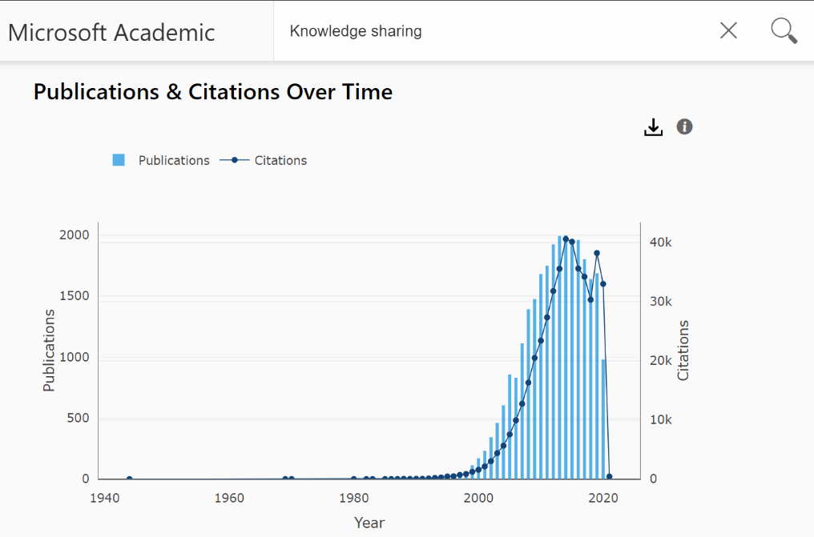
Figure. 1. Reference citations for the term "knowledge sharing" in publication resources (Microsoft Academia)
Figure 1 above shows that the number of citations for the term “knowledge sharing” in research and scientific papers in the English language amounted to three thousand in the year 2000 AD, and reached its highest peak in the period from 2010 AD to 2011 AD, where it reached forty thousand citations. Then it decreased slightly in 2018, and then increased in 2020. The number of sources that have been published reached two thousand sources. The number of recurrences of the term "knowledge sharing" during the period from 1985 to 2020 was also searched.
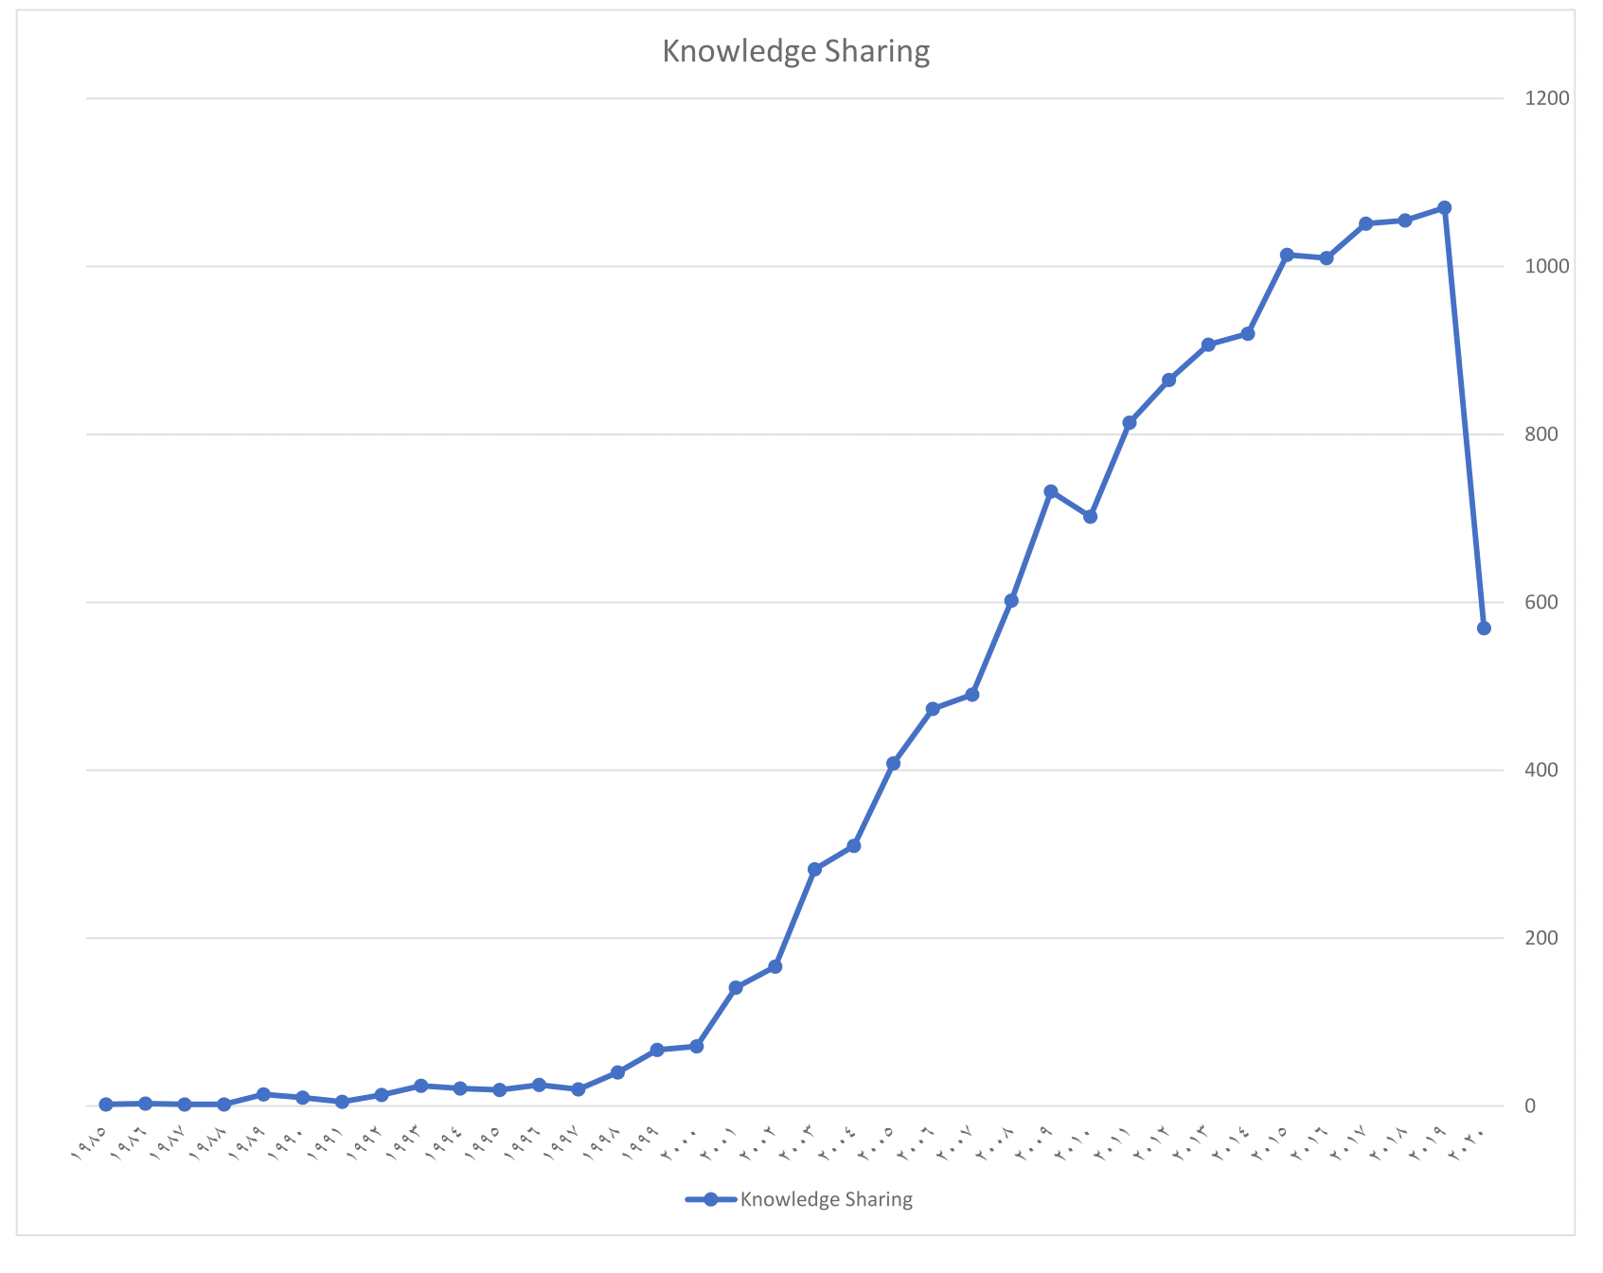
Figure. 2. The recurrence of the term "knowledge sharing" in the “Base” database
It is evident from Figure 2 that the beginning of writing research and scientific papers in the field of “knowledge sharing” was in 1985 AD, and increased until it reached its highest number of one thousand and one hundred in 2019 AD, and began decreasing sharply in the year 2020. As for the frequency of appearance of the term knowledge sharing in search engines and databases. The frequency of the term knowledge sharing in SAGE reached (3,600,091), in ProQuest (1,468,207), and in Springer (1,168,346).
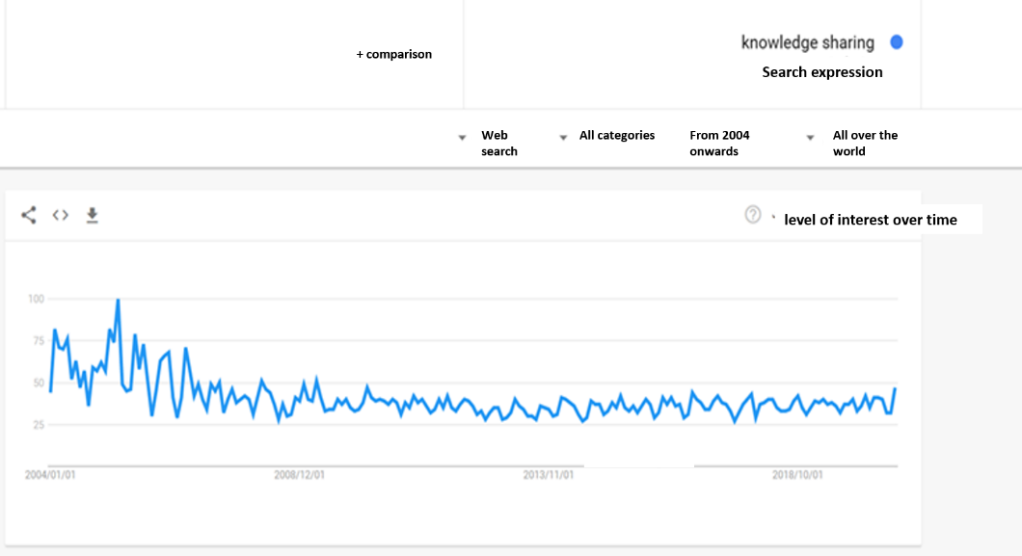
Figure. 3. The level of interest in the term "knowledge sharing" in the world from 2004 to 2020 in the Google search engine
It is clear from Figure 3 that the interest in studies of the term "knowledge sharing" has been increasing from 2004 until 2005, then it started decreasing slightly and then it was fixed at one level from 2008 until the year 2020.

4.2. Interests and research trends for the term knowledge sharing in some specialized studies

4.2.1. Arab Studies
Several Arab studies have been conducted on knowledge sharing in some fields, and they are represented in Table 1.
Table. 1. Arab studies have been conducted on knowledge sharing
# | Publication year | Author | Research or Article Title
1 | 2010AD | Rifai, Mamdouh Abdulaziz | The effect of trust among employees on knowledge sharing.
2 | 2012 AD | Hasaballah, Abdul Hafeez and Abdullah, Muhammad and Ali, Issa | The impact of the organization's internal environment for the knowledge sharing of employees: a study in the public services sector.
3 | 2013AD | Askari, Hana Jassim Mohammed | The role of organizational culture in promoting knowledge sharing.
4 | 2013AD | Jaradat, Omar | The impact of shared knowledge and organizational memory on the quality of administrative decisions in official university libraries.
5 | 2013AD | Al-Taher, Asmahan Majid and Mansour, Ibrahim Mahmoud | Knowledge sharing requirements and the obstacles facing its application in Jordanian telecom companies.
6 | 2014AD | Jawhari, Akti | The impact of strategic leadership on knowledge sharing.
7 | 2014AD | Abdel Raouf, Soha Mohamed | The impact of personal burden on the jobs of knowledge generation and sharing in industrial companies.
8 | 2014AD | Jajik, Abdelmalek and Obeidat, Sarah | The effect of knowledge sharing on developing collective competencies.
9 | 2017AD | Al-Shawaheen, Ibrahim Falah | The impact of universities' entrepreneurial orientation in activating knowledge-sharing behaviors.
10 | 2017AD | Mantash, Mohamed Abdel Hakim and Manea, Youssef Hamed | The relationship between high-performance work systems and knowledge-sharing behavior: The intermediary role of knowledge capital
11 | 2017AD | Al-Qatawneh, Manar Ibrahim and Al-Manasra, Amer and Al-Fauri, Hammoud and Abu Tayeh, Bandar Karim | The role of emotional and cognitive trust in knowledge sharing and organizational learning in business organizations.
12 | 2019AD | Safa Mubaraki | Sharing as an entry point for developing learning skills.
13 | 2020AD | Al Saud, Badr bin Saud | Transfer and share tacit knowledge and its role in crowd management during the Hajj season.

4.2.2. Foreign Studies
In 1999, the Technology Community of Denmark published a book written by (Pedersen, Kalbam, Piekkari) and entitled "Knowledge Sharing versus Knowledge Exchange." By the year (2003 AD), the Canadian Global Development Agency supervised the publication and preparation of a book entitled “Knowledge sharing: Tools, Meetings, Methods). The book dealt with how workers within organizations practice knowledge sharing in detail. In (2004 AD), there were many studies that dealt with the relationship of organizational culture with knowledge sharing such as the study of (Hendiks, 2004) entitled “Assessing the impact of organizational culture on knowledge sharing processes.”
Among the most important studies published in (2005) on the topic of knowledge sharing the study of (Riege, 2005) entitled "36 obstacles to knowledge sharing that organizational managers must be aware of". Among the studies conducted in (2006 AD) the study of (Rost and Ostenioh and Weibel, 2006) entitled "Controlling the Behavior of Knowledge Sharing". Among the studies published in (2007) dealing with (knowledge sharing), we mention a study on knowledge sharing in the public sector, entitled "Knowledge sharing in public sector organizational characteristics in interdepartmental knowledge sharing", where it indicated the importance of knowledge sharing in these organizations.
By the year (2008 AD), the study of (Peariasawy and Abu Mansor, 2008) was published on how to train employees in organizations to practice sharing the job related knowledge. It focused on searching for the best ways to encourage employees to learn how to accomplish the assigned jobs. It is entitled: "On-the job knowledge sharing: how to train employees to share job knowledge". In (2011 AD) the study of (Lilleoere and Holme Hasen, 2011) entitled "Knowledge sharing Barriers and Enablers” was published.
Then, in 2012, the book of (Sulaiman) titled “Knowledge-Sharing Behavior” was published by UUM Press, Malaysia, which is an acronym for the University of Utara, Malaysia. In (2015 AD), a collection of studies was conducted on knowledge sharing in organizations. Among the most important studies is the study of (Ashwini and Harinarayana) entitled "Influential Theories of Knowledge Sharing". It explained the importance of sharing knowledge in creating opportunities to maximize the daily creative activities of the organization's employees to achieve job performance.
Also, in the year (2020), one of the studies discussed, among others in the same year, the topic of knowledge sharing. It was titled "Do Work Engagement and Transformational leadership facilitate knowledge sharing? A perspective of conservation of resources theory”. There are also other efforts made by some researchers in the literature on the topic of knowledge sharing:
In (2010 AD), (Raymond, Sheng Wang A. Noe, 2010) reviewed the studies that dealt with (knowledge sharing) in the period from 1999 AD to 2008 AD. Their review also included three research papers, one of which was published before 1994 AD, and the last two studies were published in 1996 AD. The total number of research studies in the period from 1999 to 2008 amounted to about (76) quantitative and qualitative studies, and three were added to them, so there were (79) studies dealing with the topic of “knowledge sharing”. The concerned three added studies were carried out by (Constant, Kiesler & Sproul, 1996; Lam, 1996). The studies focused on six areas that dealt with the topic of knowledge sharing and its relationship to some variables, including information and communication technology (ICT).
By the year (2013), Ribiere and Walter studied keyword recurrence and content analysis of about 235 articles published in the Journal of Knowledge Management (KMRP). In addition, in the period between 2003 and 2012, they found a great and continuous interest in research topics related to knowledge sharing through keyword analysis.
Sun and Kim [24] also analyzed (65) studies in the literature of knowledge sharing studies from 2005 to 2013 including ongoing developments for knowledge sharing. They pointed out that knowledge sharing has become one of the main factors for upgrading and developing the economy and organizational creativity in the era of the knowledge economy. Also, (Al-Haaj and Anwar, 2016) systematically reviewed about (64) articles published in the Journal of Knowledge Management from 2010 to 2015. It included qualitative and quantitative studies on knowledge management and knowledge sharing focusing on trends, issues and challenges in this field.
Then, in (2016 AD), some researchers systematically reviewed the relationship of knowledge sharing with knowledge management and clarified the trends, issues and challenges facing the knowledge sharing process in a study entitled “A systematic review of Knowledge Management and Knowledge Sharing: Trends, Issues, and Challenges, 2016”.

4.3. Discussion
It turns out that there is a great interest in the term information and communication technology in foreign studies while Arab studies paid little attention to it. The study showed that foreign studies have dealt with the term information and communication technology and its impact on some variables in organizations such as performance, organizational culture, leadership, creativity, innovation...etc. Many foreign studies have also dealt with the relationship of information and communication technology to knowledge management in general, and to the dimensions and processes of knowledge management in particular. However, few Arab studies dealt with the relationship of information and communication technology to knowledge management and its processes and dimensions [25]. The study revealed that the term knowledge sharing has been the subject of many foreign studies, but it has not been found in Arab studies.
The study showed that the term knowledge sharing and its relationship to some variables in organizations have found great interest in foreign studies on the contrary of Arab studies which were few. With regard to the relationship of information and communication technology to knowledge sharing, the study showed that it found a very great interest in foreign studies, but a scarcity in Arab studies. The study revealed that the issue of the relationship of information and communication technology with knowledge sharing began in 1991 AD, with a foreign study entitled "Technology Support for Knowledge Sharing". The study showed that the term “Information and communication technology and knowledge sharing” was repeated more than 2699 times in one of the “Mendley” digital search engine during the period from 1991 to 2020 AD.
The study indicated that many conferences, workshops and scientific communities that dealt with the topic of "information and communication technology and knowledge sharing", were held especially in the period from 2005 to 2017, and covered a variety of related topics. The study revealed that most of the studies conducted during the period from 1991 to 2020, which dealt with the relationship of information and communication technology with knowledge sharing, were mostly in the private sector, especially business organizations. Few of them were conducted in the public sector, especially in the field of education, and in particular higher education.
The study showed that there is a repetition and great similarity in the titles of foreign research efforts. However, there is a discrepancy in the presentation and content, different results, and different descriptive styles that would enrich the field despite the similarity in the title. In addition, these studies that were similar in the title were conducted in different environments, which makes this similarity without a great effect. It is noted that despite the lack of Arab studies on the subject of information and communication technology, there was a clear beginning of interest in the period from 2014 to 2020, when several studies appeared that dealt with the relationship of information and communication technology with knowledge sharing.

Conclusion
Through a review of the literature on the subject of “information and communication technology and knowledge sharing” and after tracing studies in this field, it became clear that the relationship of technology and knowledge sharing began since 1991, and studies continued in this way using the word technology in general until the emergence of the term ICT. Then, studying the relationship of information and communication technology began to emerge, especially foreign studies, and the unpublished study prepared by (Kempees, 1998) and mentioned by Hendriks was the first study in this field. Besides, and since 1999 AD, studies began to be more active in this subject and continued until 2020. During this period, the tendencies of the studies were different, that is, they did not focus on one aspect, but rather their orientations were diverse. Many of them focused on the different effects of information and communication technology on the processes and practices of knowledge sharing in organizations, some focused on the psychological aspect of the motivation process for individuals in organizations towards the use of information and communication technology (ICT) in knowledge-sharing processes, others focused on the process of encouraging and supporting the use of information and communication technology in sharing knowledge, some of them also stressed the impact of some organizational variables (organizational environment, organizational trust, organizational culture, organizational creativity, organizational commitment....etc) on information technology and then on knowledge sharing processes. In addition, some studies focused on the obstacles and restrictions of using information and communication technology in knowledge sharing. Another set of studies focused on technological factors, social factors, and organizational factors affecting the relationship of information and communication technology with knowledge sharing. Other studies were geared towards studying the impact of information and communication technology (ICT) tools and means on the practice and sharing of knowledge in the organization.
The researcher noted that there is a weakness in the study of the subject of information and communication technology and its relationship to the sharing of knowledge in the Arab world, as indicated by the small number of the Arab studies. The focus of foreign studies was on the private sector. The public sector has not received sufficient applied studying. Likewise, the reviewed studies did not address the relationship of information and communication technology tools and the impact of each of its tools on the knowledge-sharing process. Moreover, it did not address the development of models to clarify how to activate the practices and processes of knowledge sharing using information and communication technology and other tools.

References
- B. Naghdipour, “ICT-enabled informal learning in EFL writing,” J. Second Lang. Writ., vol. 56, p. 100893, 2022, doi: https://doi.org/10.1016/j.jslw.2022.100893.
- B. Acharya, J. Lee, and H. Moon, “Preference heterogeneity of local government for implementing ICT infrastructure and services through public-private partnership mechanism,” Socioecon. Plann. Sci., vol. 79, p. 101103, 2022, doi: https://doi.org/10.1016/j.seps.2021.101103.
- A. Awad and M. Albaity, “ICT and economic growth in Sub-Saharan Africa: Transmission channels and effects,” Telecomm. Policy, p. 102381, 2022, doi: https://doi.org/10.1016/j.telpol.2022.102381.
- I. K. Ofori and S. A. Asongu, “ICT Diffusion, Foreign Direct Investment and Inclusive Growth in Sub-Saharan Africa,” Telemat. Informatics, vol. 65, p. 101718, 2021, doi: https://doi.org/10.1016/j.tele.2021.101718.
- I. K. Ofori, D. B. Osei, and I. P. Alagidede, “Inclusive growth in Sub-Saharan Africa: Exploring the interaction between ICT diffusion, and financial development,” Telecomm. Policy, vol. 46, no. 7, p. 102315, 2022, doi: https://doi.org/10.1016/j.telpol.2022.102315.
- J. DING, J. LI, J. LIU, W. ZHANG, and X. JIA, “ICT-based agricultural advisory services and nitrogen management practices: A case study of wheat production in China,” J. Integr. Agric., vol. 21, no. 6, pp. 1799–1811, 2022, doi: https://doi.org/10.1016/S2095-3119(21)63859-5.
- H. Njangang, A. Beleck, S. Tadadjeu, and B. Kamguia, “Do ICTs drive wealth inequality? Evidence from a dynamic panel analysis,” Telecomm. Policy, vol. 46, no. 2, p. 102246, 2022, doi: https://doi.org/10.1016/j.telpol.2021.102246.
- J. Zhu and S. S. C. Li, “The non-linear relationship between ICT use and academic achievement of secondary students in Hong Kong,” Comput. Educ., p. 104546, 2022, doi: https://doi.org/10.1016/j.compedu.2022.104546.
- S. A. Butt, E. A. Elhadjamor, I. Pappel, E. Õunapuu, and D. Draheim, “A Knowledge Map for ICT Integration in the Silver Economy,” Procedia Comput. Sci., vol. 181, pp. 693–701, 2021, doi: https://doi.org/10.1016/j.procs.2021.01.220.
- P. Ntiri, C. Ragasa, S. A. Anang, J. K. M. Kuwornu, and E. Nimorme Torbi, “Does ICT-based aquaculture extension contribute to greater adoption of good management practices and improved incomes? Evidence from Ghana,” Aquaculture, vol. 557, p. 738350, 2022, doi: https://doi.org/10.1016/j.aquaculture.2022.738350.
- P. Evangelista and J. Hallikas, “Exploring the influence of ICT on sustainability in supply management: Evidence and directions for research,” Clean. Logist. Supply Chain, vol. 4, p. 100051, 2022, doi: https://doi.org/10.1016/j.clscn.2022.100051.
- M. Park et al., “ICT-based person-centered community care platform (IPC3P) to enhance shared decision-making for integrated health and social care services,” Int. J. Med. Inform., vol. 156, p. 104590, 2021, doi: https://doi.org/10.1016/j.ijmedinf.2021.104590.
- K. Laursen and V. Meliciani, “The role of ICT knowledge flows for international market share dynamics,” Res. Policy, vol. 39, no. 5, pp. 687–697, 2010, doi: https://doi.org/10.1016/j.respol.2010.02.007.
- F. Yassin, J. Salim, and N. S. @ Ashaari, “The Influence of Organizational Factors on Knowledge Sharing Using ICT among Teachers,” Procedia Technol., vol. 11, pp. 272–280, 2013, doi: https://doi.org/10.1016/j.protcy.2013.12.191.
- M. Eisenbardt, “ICT as a tool for gaining and sharing knowledge,” Procedia Comput. Sci., vol. 192, pp. 1839–1847, 2021, doi: https://doi.org/10.1016/j.procs.2021.08.189.
- A. Jawhara, “The Impact of Strategic Leadership on Knowledge Sharing": Case Study of an Algerian Hotel Group.” PhD thesis, University of Biskra, 2014.
- Z. Albinahmed, “Social networking system for Saudi patients to share experience and improve awareness: A mobile application,” Comput. Methods Programs Biomed., vol. 205, p. 105983, 2021, doi: https://doi.org/10.1016/j.cmpb.2021.105983.
- A. Ziafati Bafarasat and E. Oliveira, “Prospects of a transition to the knowledge economy in Saudi Arabia and Qatar: A critical reflection through the lens of spatial embeddedness and evolutionary governance theory,” Futures, vol. 129, p. 102731, 2021, doi: https://doi.org/10.1016/j.futures.2021.102731.
- M. Y. Alsheikh et al., “Community Pharmacy Staff Knowledge, Opinion and Practice toward Drug Shortages in Saudi Arabia,” Saudi Pharm. J., vol. 29, no. 12, pp. 1383–1391, 2021, doi: https://doi.org/10.1016/j.jsps.2021.09.001.
- A. M. Alshabi, M. A. K. Shaikh, I. A. Shaikh, S. A. Alkahtani, and A. Aljadaan, “Knowledge, attitude and practice of hospital pharmacists towards pharmacovigilance and adverse drug reaction reporting in Najran, Saudi Arabia,” Saudi Pharm. J., 2022, doi: https://doi.org/10.1016/j.jsps.2022.04.014.
- F. Ghabban, A. Selamat, and R. Ibrahim, “New model for encouraging academic staff in Saudi universities to use IT for knowledge sharing to improve scholarly publication performance,” Technol. Soc., vol. 55, pp. 92–99, 2018, doi: https://doi.org/10.1016/j.techsoc.2018.07.001.
- M. Arif, N. Qaisar, and S. Kanwal, “Factors affecting students’ knowledge sharing over social media and individual creativity: An empirical investigation in Pakistan,” Int. J. Manag. Educ., vol. 20, no. 1, p. 100598, 2022, doi: https://doi.org/10.1016/j.ijme.2021.100598.
- Y. Zhou, “Analysis of Influencing Factors of Knowledge Dissemination and Sharing Based on the SEIRR Model,” Data Inf. Manag., p. 100010, 2022, doi: https://doi.org/10.1016/j.dim.2022.100010.
- H. Sun and G. Kim, “The composite impact of ICT industry on lowering carbon intensity: From the perspective of regional heterogeneity,” Technol. Soc., vol. 66, p. 101661, 2021, doi: https://doi.org/10.1016/j.techsoc.2021.101661.
- M. S. Karim, S. Nahar, and M. Demirbag, “Resource-Based Perspective on ICT Use and Firm Performance: A Meta-analysis Investigating the Moderating Role of Cross-Country ICT Development Status,” Technol. Forecast. Soc. Change, vol. 179, p. 121626, 2022, doi: https://doi.org/10.1016/j.techfore.2022.121626.

