Understanding Users’ Attitude to Social Endorsement Advertising of Embarrassing Product
Chih-Chien Wang ^{1,*}, Yolande Yunhsiou Yang ², Meng Hsuan Chiang ³
^{1,2,3} National Taipei University, Taiwan
¹ wangson@mail.ntpu.edu.tw*; ² yolande@mail.ntpu.edu.tw; ³ carriechiang1995@gmail.com
* corresponding author

(Received April 24, 2021, Accepted April 24, 2021, Available online April 25, 2021)
Abstract
Users on social media have increased rapidly in recent years, social media advertising has become a popular marketing tool for companies to promote their products. A feature of social media advertising is that marketers can use customers' online behavior to create customized advertisements, which are also known as targeting ads. In this study, we conducted experimental testing 2 (advertising type) X2 (product type) to see if increased knowledge of social advertising would influence users' attitudes towards ads. We separated two different types of advertising on Facebook, namely remarketing and social support, and two different types of products, which advertised general products and ads about embarrassing products. The results of this study are that the increase in advertising knowledge is able to (1) affect the perceived value of advertisements from different types of products and (2) different types of advertisements do not affect user attitudes towards advertisements. For future research, we recommend focusing primarily on the demographic and environmental variables of digital advertising users about embarrassing products.

Keywords: Social Media Advertising; Privacy Concern; Embarrassing Product; Social Media; Targeting Advertising; Social Endorsement Advertising; Advertising Knowledge;

Introduction
The use of social media including Facebook, Instagram has grown in popularity in recent years. Data from statistics shows that Facebook users have made profits from 100 million to 2.7 billion over the last 10 years Statista [1]. Based on the population on social media, the influence and influence of social networks is getting wider and deeper. In this regard, advertising on social media has become one of the most important tools for marketers to undertake. Advertising on social media never only shows ads on the platform. There are several types of advertising, such as remarketing ads (also known as targeting ads) and social support ads that allow the ads to provide information to users more precisely and increase the effectiveness of the ad.
Remarketing ads are advertisements that are based on customers' online information, including information disclosed to social media and their online behavior. Meanwhile, a social endorsement ad is a type of ad that displays your friends' preferences online. Lambrecht and Tucker [2] have shown that more and more marketers are starting to use remarketing ads, Jung (2017) also shows that ads with more self-relevance are able to attract customer attention. However, even though these ads are shown to every user, not all of them really know the techniques of advertising on social media.
In addition, with the e-commerce trend, many types of products are sold online, including practical products, innovative products and so on. Among them, embarrassing products such as condoms, sex toys are usually considered as products that are difficult to promote. don't want to see such content on social media for their privacy concerns. With such product type barriers, nowadays marketers can take advantage of online advertising to increase exposure of embarrassing products and reach customers more precisely.
Many studies discuss types of advertisements between products of different genders, different cultures, but rarely discuss embarrassing products. Therefore, in this study we will discuss more about an embarrassing product, and the purpose of the research is to find out:
- The difference between user attitudes towards common products and embarrassing products displayed on social media
- The influence of user attitudes towards advertisements about products is embarrassing after increasing knowledge about online advertising.
- Difference in attitude between targeting advertising and social support advertising after increasing knowledge of online advertising.

Literature Review

Social Media Advertising
As the digital market has developed in recent years, online advertising has become a popular tool for marketers to promote their products and services. With features of higher outreach and lower costs, Shaban [4] pointed out that the number of social media advertising has increased and is expected to surpass traditional advertising in a few years. In addition, by connecting to social media and the internet, it becomes possible for marketers to accumulate users. behavior much easier than in the past. As a result, advertising can be more personalized, and this type of advertising is also known as "targeting advertising", which has been discussed by Samat, Acquisti [5] in previous research that this type of advertising is based on a similar recommendation system technique. who share information with customers through preferences and behaviors. In our research, we divided targeting ads into two parts, namely remarketing ads and social support ads. Remarketing ads are a common type of ad that displays content to users based on their advertisements. interests' and other online behaviors. Social support ads are based on a similar technique but with friend recommendations on social media. We will make a further introduction to the two types of advertising in the following sections (2.2 and 2.3).

Remarketing Advertising
Ad targeting is defined as: "the practice of tracking a person's online activities to deliver advertisements tailored to individual interests" Commission [6]. Some researchers say that this kind of advertisement is able to predict buying behavior. Lambrecht and Tucker [2] show that more and more marketers are using retargeting ads practically, and this type of ad is capable of creating higher effectiveness than Samat's standard banner, Acquisti [7] mentioned in their research on awareness of targeting on customer attitudes that industry supports the use of this type of advertising because of its higher click-through rate and sales. once visited the page; however, Sangat, S., Acquisti, A., & Babcock, L. (2017) found that ad targeting was not always used. They found that tracked awareness leads to reluctance to disclose user information and even results in ad avoidance of advertisements.

Social Endorsement Advertising
In recent years, there has been another type of targeting advertising, which we refer to as social support advertising in our research. This type of ad is displayed with recommendations from friends or people you know on social media. Mohsin Butt and Cyril de Run [8] have discussed that advertising on groups from the same ethnic aspect, which means that information from people with the same background will be more persuasive and lead to better advertising effectiveness. However, they may be a more effective advertisement, it also reveals the behavior of your friends. Johnson, Egelman [9] found that although there were options for people to control their privacy and content on social media, they were unable to find out who the real audience was in their research that focused on use on Facebook.

Embarrassing Product Advertising
Shyness is defined as "a self-conscious emotion in which a person feels awkward or confused in the company of another or out of concern for another person, such as, for example, being observed engaging in an action that may elicit slight disapproval from others." Jiang, Drolet [3] have shown that shame often makes people reluctant to understand further about the product, especially to people who have high self-awareness. Puntoni, de Hooge [10] also pointed out that online users will feel more intentional about their targeting if they are the target of embarrassing content. In this case, there may be more barriers for marketers to deliver the value of their products to customers. Lau-Gesk and Drolet [11] found that public self-awareness was positively associated with purchase intentions of embarrassing products, and indicated that people with higher self-awareness would avoid embarrassing products because of the effect of the spotlight. Li, Yang [12] have consolidated previous research that discusses embarrassing product buying behavior and found that there are four strategies that people usually do, namely abandoning purchases, delaying purchases, additional purchases, and compensating purchases. According to Choi Jiang [13], they have shown that people who reject embarrassing disclosure are due to social exchange theory. People may feel that their social status is in jeopardy if the information is disclosed by them. Among these literatures it makes it difficult for marketers to target the general public, besides that there is rarely research that discusses marketing in related fields. So, in our research, we prepared an outrageous product in our scenario to see if there were any different effects to the common product.

Privacy Concern to Social Media Advertising
2.5.1. Privacy Concern to Internet Usage
The Internet serves as a platform for online companies to create profitable relationships with consumers, including increased data generation and collection, globalization of information and communications, and a lack of centralized control mechanisms. Evans [14] points out that the structure of online communication allows digital marketers to learn more about online users than can be done with traditional media such as print, radio, and television. Among the increasing use of the internet, privacy concerns have been increasing with users. Castañeda, Montoso [15] discussed various dimensions of customer online privacy concerns in previous research and found that all e-commerce professionals are aware of what is meant when privacy is mentioned. Brown and Muchira [16] show that consumers who receive unwanted and unsolicited communications from companies via the Internet are less likely to purchase products online. Thus, through literature review, it has presented the importance of privacy and should not be overlooked.
2.5.2. Privacy Concern to Social Media Advertising
Regarding the use of social media, researchers have mentioned issues related to social media privacy (Fox and Royne [17]) and customer behavior (Kim and Huh [18]). Jung [19] has found that privacy concerns do not affect social media behavior but will increase awareness of information on social media. In contrast, Youn [20] has conducted related research among adolescents and found that they will initiate their privacy protection behavior, once they feel their data is being put into practice with marketers. Based on privacy protection, Zlatolas, Welzer [21] has discussed its effect with communication privacy management (CPM) theory, which interprets the intent of users sharing their information under the matter of privacy. Bright, Kleiser [22] have mentioned that the reason people feel annoyed with social media is that the information is too much accessed and overloaded with their personal information. Therefore, through previous research, they have shown the importance of privacy concerns to the online world.

Knowledge
2.6.1. Knowledge to Online Advertising
Smit, Van Noort [23] show that users still have sufficient knowledge about online advertising, especially cookie techniques. According to the findings of Smit, Van Noort [23], they cited insufficient knowledge of online advertising. People who are online can find out about online advertisements, many of them don't really understand how and why ads are shown to them. They also found that the presence of knowledge-related information can reduce people's knowledge. Therefore, in our study, we focused on the post-increase advertising knowledge hypothesis to compare the attitudes of users with different levels of knowledge.
2.6.2. Knowledge to Social Media Advertising
Basically the difference between online advertising and social media advertising is the level of user engagement, shown by Tiago and Veríssimo [24] in a study comparing digital advertising and social media advertising. Social media advertising involves relationships with other people, and can have implications for privacy concerns.
2.6.3. Knowledge and Privacy Concern
Fox and Royne [17], Ham and Nelson [25]. Tucker (2014) also shows that introducing privacy controls increases the effectiveness of personalized advertising by reducing reactance. In such situations, marketers should focus more on informing online advertising information and reducing user worries. The effect has been validated by Send, Van Noort [23]. Above all, the literature suggests that increased knowledge will have an impact on customer privacy concerns.

Method

Hypotheses
Among the discussion with related literature, our study proposes the hypotheses after enhancing the knowledge about advertising:
H1a: Remarketing Ads will positively affect the perceived value of advertising and decrease ad-clicking behavior.
H1b: Remarketing ads will positively affect irritation to ads and reduce ad-clicking behavior.
H1c: Social support advertising will positively affect the perceived value of the ad and decrease ad-clicking behavior
H1d: Social support advertising positively influences strong ad irritation and reduces ad-clicking behavior
H2a: Ads with general products will positively affect the perceived value of the ad and reduce ad-clicking behavior.
H2b: Ads with a common product type will positively affect the perceived value of the ad and decrease ad clicking behavior
H2c: Ads with an embarrassing product will negatively impact the perceived value of the ad and decrease ad-clicking behavior.
H2d: Ads with an embarrassing product type will positively affect the perceived value of the ad and decrease ad-clicking behavior

Procedure
In our study, we released paper questionnaires to students in Chilee University of Technology before and after a lecture related to the technique of online advertising. The measurements of both questionnaires include privacy concern, advertisement behavior, perceived advertising value and irritation. It took respondents 10 minutes in average to fill each questionnaire. We exclude the product embarrassment in our after-class questionnaire, which is the measurement for distinguishing our product types. It took respondents 10 minutes in average to fill each questionnaire.

Measurement
Subjective knowledge asked respondents to fill in five multiple questions about social advertising knowledge, which will be taught in the course to see if our respondents increase related knowledge. Advertising knowledge is to measure the objective knowledge of social advertising. In our study, we measured it with 6 items adopted from Ham and Nelson [25], and originally developed from Bearden, Hardesty [26]. The measurements were submitted as "I understand how marketers show me personalized ads using behavior tracking", and "I can see through the ad personalization technology used to make me buy in online advertising.
To measure whether the product type is considered an embarrassing product or a common product by our respondents, we adopt a 3-item scale from Jiang, Drolet [3]. The two-dimensional 6-item privacy concerns scale was undertaken to measure privacy concerns in our study, which are social media privacy and privacy concerns. Social media privacy according to Bright, Kleiser [27], while privacy concerns according to Lee and Hong [28], was originally developed by Buchanan, Paine [29]. However, Cronbach's α was lower than 0.7 in three items from Bright, Kleiser [22], so we removed three items from the antecedent analysis.
A three-item scale was used to measure the perceived value of advertising, which represents a positive dimension of advertising attitudes in our study. These scales were originally developed by Ducoffe [30] and later revised by Ramadan, Abosag [31]. A three-item scale was used to measure advertisement irritation, which represents negative advertising attitudes in our study. Two negative advertising attitude variables were initially discussed in Högström and Wallin [32], including irritation and distraction. We selected three items on the advertisement irritation scale, most associated with adoption according to our study. The scale originally developed by Tang et al. (2015), Moore et al. (2015), Birmingham (2015), Schimdt & Eisend (2015), McCoy et al. (2017) and Laroche et al. (2006). Finally, a three-item scale was measured for advertising behavior, a scale originally developed by Holbrook and Batra [33] and later revised by Lee and Hong [28]. Measurements are shown in appendix A. Original scale words were asked to match the research objectives of this study, and all questions were measured on a 7-point Likert scale, where a score of 1 indicates strongly disagree and 7 indicates strongly agree.

Results

Samples
Table. 1. Statistics of Construct Items
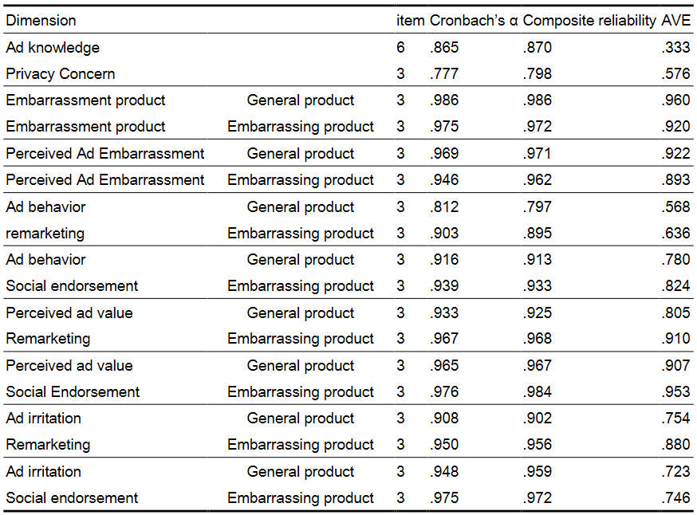
Table. 2. Statistics of Construct Items. (Rich Knowledge)
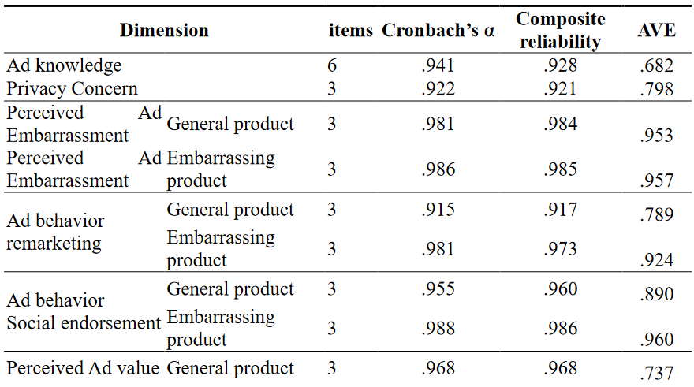

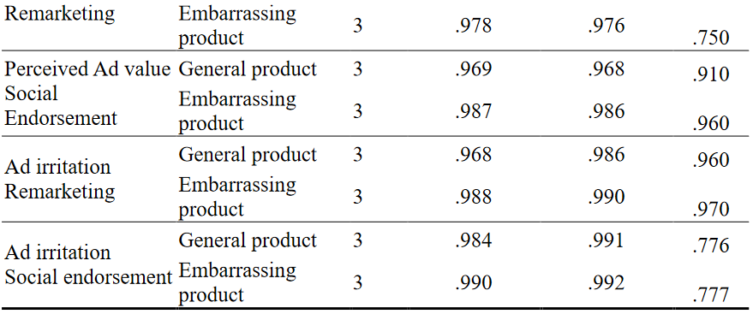

Identify the Headings
In this study, we collected the gender, age and frequency of our respondents using Facebook for further discussion. The research sample was 57.8% male and 41.2% female. Their average age is 22 years, and the majority of the frequency uses Facebook several times a day, with the percentage of 72.5%, while 19.6% of our respondents use Facebook several times a week, 2% once a week and 6.9% use Facebook a week once. The descriptions of our respondents are shown in Table 3. In addition, the mean and standard deviation of each variable is shown in Table 4.
Table. 3. Description of respondents in this study
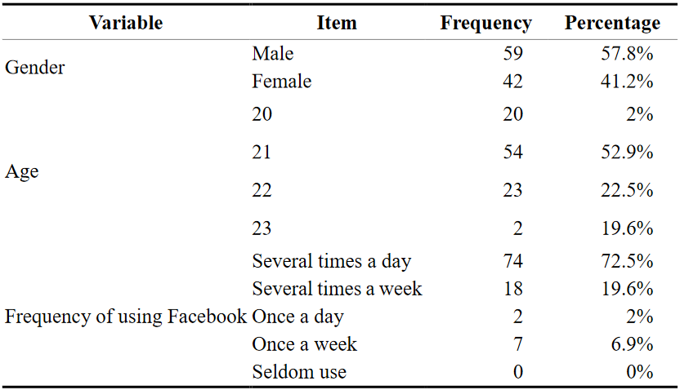
Table. 4. Average and standard deviation of this study
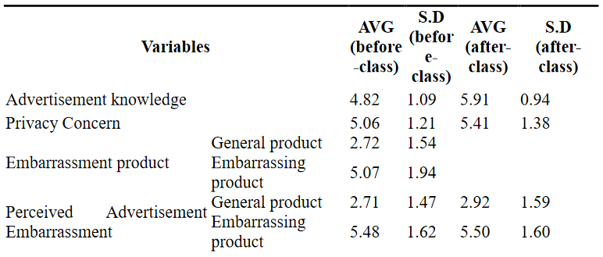

Reliability and Validity
Satisfactory loading (> .7) and AVE (>. 5) showed good convergent validity. In addition, the square root of AVE for all measures was greater than the correlation of the variables, and descriptive statistics showed that the constructs ranged in the normal distribution. Therefore, the results showed good discriminant validity. In addition, Cronbach's α of each variable indicates> 0.7 that all measurement items are reliable. Reliability test and validity test are shown in Table 5 and Table 6.

Table. 5. Correlations between constructs before class (AVE and squared correlations)
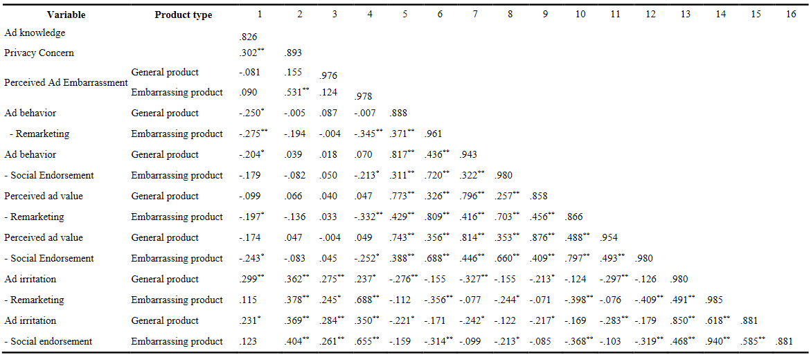

Table. 6. Correlations between constructs after class (AVE and squared correlations)
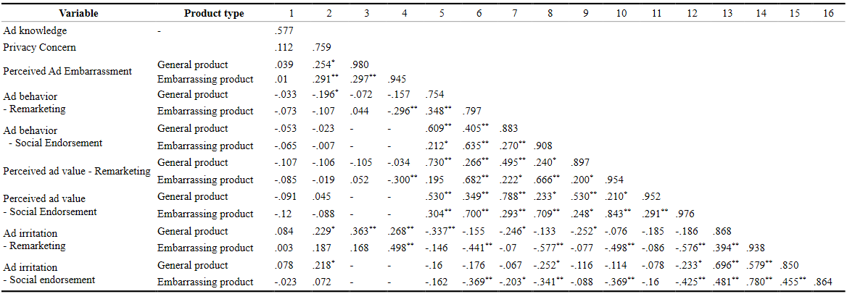

ANOVA Analysis
ANOVA with the perceived value of advertising as the dependent variable produced a significant effect on the type of product (F = 88.128, p <0.01), knowledge (F = 7.403, p = 0.081), type of advertisement (F = 4.907, p = 0.29), as well as significant interaction effect (F = 10.209, p = 0.02; see Table 7).
Since the interaction effect (F = 10,209, p = 0.02) was significant, we next performed a posthocc comparison. Specifically, our findings reveal that (1) respondents with rich advertising knowledge demonstrated the highly perceived value of advertising in each product type and obtained significantly higher returns on common products, and (2) respondents with high advertising knowledge. rich does not show significant influence in various types of advertising. Therefore, H1a, H1c, H2a and H2c are supported.

Table. 7. Repeated measure ANOVA test among advertisement knowledge toward product types
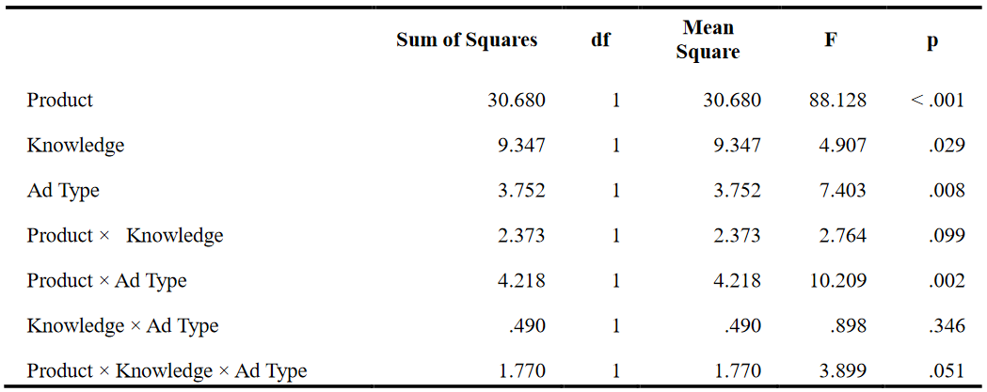
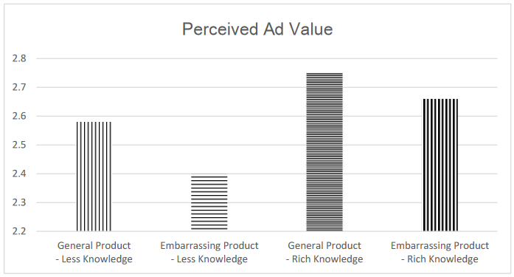
Fig. 1. Mean Perceived Ad Venue by different product types and different level of advertising knowledge
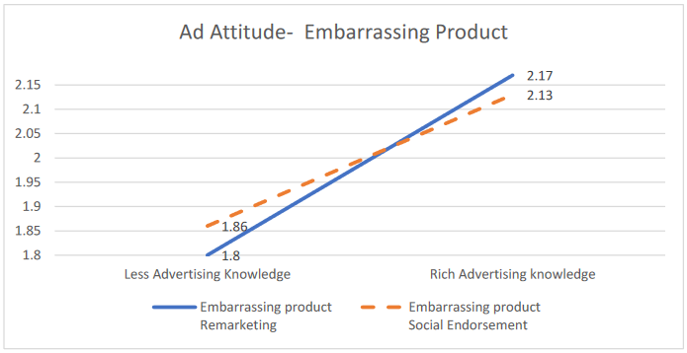
Fig. 2. The correction effect between advertising attitude and embarrassing product
Table. 8. Post Hoc Comparison among advertisement knowledge toward product types
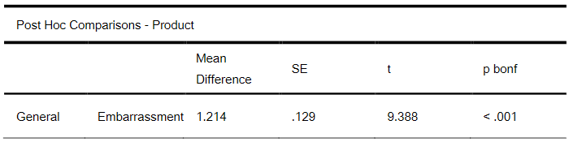
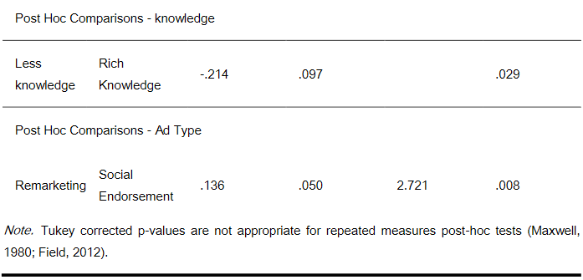
ANOVA with advertisement irritation as the dependent variable only reveals the significant effects of product types (F = 88.128, p <0.01). It does not show significant effects of knowledge (F = 7.403, p = 0.081) and ad types (F = 4.907, p = 0.29; Table 8). In general, people with richer advertising knowledge leads to a higher level of advertising irritation in different product types and people with less related knowledge. Moreover, the results show that the type of advertisements do not affect the irritation of respondents. Hence, is supported H2d, but H1b, H1d, H2b, is not.
Table. 9. Repeated Measure ANOVA test among advertisement knowledge toward product types
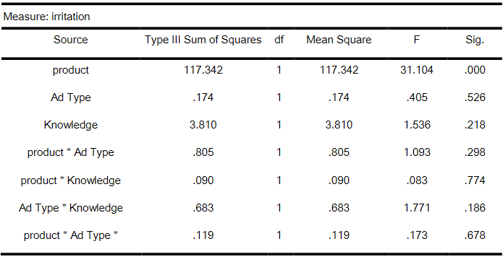
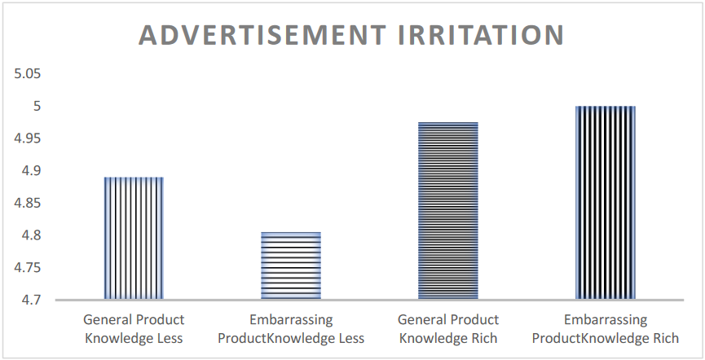
Fig. 3. Mean Ad Irritation by different product types and different level of advertising knowledge
ANOVA with advertising behavior as the dependent variable only showed a significant effect of product type (F = 67,780, p = 0.00) and knowledge (F = 1.075, p = 0.09), but did not show the type of advertisement (F = 1.075, p = 0.302; Table 10). In general, people with richer advertising knowledge lead to higher levels of advertising behavior on different types of products than people with less related knowledge. The results showed that the type of advertisement did not affect the respondents' behavior.
Table. 10. Repeated Measure ANOVA test among advertisement knowledge toward product types
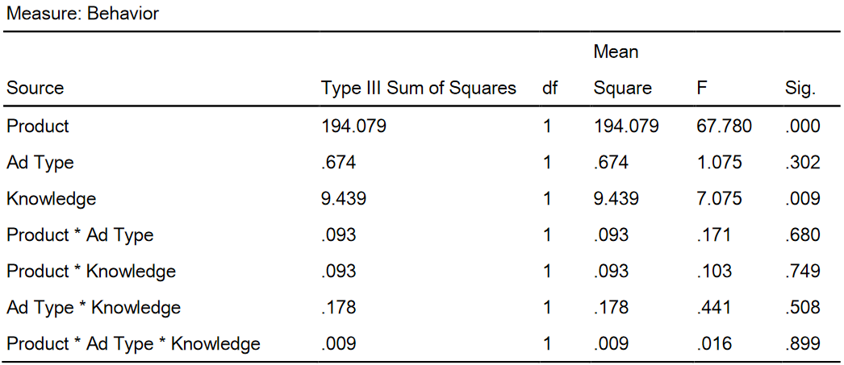
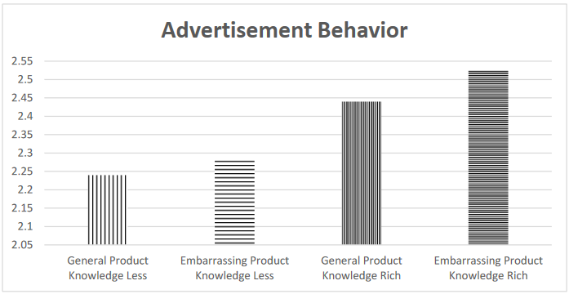
Fig. 4. Mean Ad Behavior by different product types and different level of advertising knowledge

Discussion

5.1. Summary
We investigated the influence of knowledge about targeting on individuals' attitudes and behavior towards advertising. Our findings show that, among individuals who have more knowledge about online advertising increases the perceived value of advertising to different types of products and types of advertisements. We did not find the effect of distraction awareness and behavior on ad type among individuals with more knowledge of ad targeting techniques.

5.2. Theoretical Contribution
This research contributes to the personal literature and social exchange theory in the aspect of product embarrassment. Choi, Jiang [13] who found a link between privacy and shyness. Through our research results it extends the theory of CPM in product content which is a shame. Apart from that, we also show that customers are concerned about their disclosures which are embarrassing because of social exchange theory. Although advertising researchers have only recently begun to realize the importance of exploring the influence of social contexts, research into online advertising about embarrassing products is still insufficient. Our results describe a combination of online behavior and to new directions in a related area.

5.3. Practical Contribution
The results of this study offer useful guidelines for practice. In today's society, online advertising is always in demand for marketers. In addition to traditional advertising techniques that focus on disclosing information to customers, online advertising makes it possible to take advantage of personal data and distribute advertisements in an active and appropriate manner. This study describes consumer attitudes in interacting with online advertising on social media after gaining knowledge about how advertising works. We found that with more knowledge about online advertising, people showed a more positive attitude towards advertising, which is consistent with the results from Fox and Royne [17]. They have indicated that promotions with a clear privacy policy can improve customer attitudes towards advertising. In addition, our results are also supported by an embarrassing product, which is a type of ad that is considered difficult to promote. can increase their advertising efficiency by implying customers that their information can be used for future promotions.

5.4. Limitations
This work presents several limitations. First, to ensure that our respondents acquire the same knowledge of online advertising, they mainly come from campus. It is important to validate our results on targeted advertising with broader demographic variables, such as age. The second limitation is our scale validation and evaluation of our attitude about online advertising is only done for personal use scenarios. It is important to validate (and, if necessary, modify) our findings for other types of scenarios such as unwanted public exposures, semi-public situations and public situations. Finally, our study does not take into account user demographic factors, which have been discussed by Lau-Gesk and Drolet [11] with the effect of self-awareness in dealing with embarrassing problems and Barnier and Valette-Florence [34] discuss different purchase intentions of embarrassing products for different genders and ages. It might be interesting to explain it in future work by including basic conditions with different scenarios and personal traits.

5.4. Future Research Suggestions
Lambrecht and Tucker [2] have stated that there are three aspects in the discussion of shame, namely the product, the consumption environment, and the psychological characteristics of the customer. The consumption environment is a discussion of "where" shame occurs, such as public or private. The psychological characteristics of customers are a discussion of the respondent's geographic factors, such as gender, age and personal characteristics; However, in our research we focused only on product aspects to measure advertising effectiveness. Thus, in future research, we can focus on the consumption environment and psychological characteristics of customers for further discussion. The consumption environment can be done by regulating different situations such as comparisons of behavior between public and private disclosures of one's content on social media. Choi, Jiang [13] have addressed the related issues of embarrassing disclosure affecting privacy violations on social media, and indicated that accidental disclosure could increase one's perception of privacy violations. In addition, exposure of embarrassing content can even affect their social status according to social exchange theory. In addition, the psychological characteristics of customers can be divided into demographic characteristics and psychological characteristics. Demographic characteristics are factors such as gender, age and region. Psychological characteristics are factors that measure the level of self-awareness, self-esteem and so on. Jiang, Drolet [3] have found a relationship between levels of self-awareness and shame avoidance and show that people with higher self-awareness tend to have higher levels of shame-avoidance. Overall, we think it will be interesting for further research to measure two other aspects of the problem of online advertising on embarrassing products.

References
- Statista. Number of monthly active Facebook users worldwide as of 3rd quarter 2018 (in millions). 2018; Available from: https://www.statista.com/statistics/264810/number-of-monthly-active-facebook-users-worldwide/#0.
- Lambrecht, A. and C. Tucker, When does retargeting work? Information specificity in online advertising.Journal of Marketing Research, 2013. 50(5): p. 561-576.
- Jiang, L., A. Drolet, and C.A. Scott, Countering embarrassment-avoidance by taking an observer's perspective.Motivation and Emotion, 2018: p. 1-15.
- Shaban, H. Digital advertising to surpass print and TV for the first time, report says. 2019; Available from: https://www.washingtonpost.com/technology/2019/02/20/digital-advertising-surpass-print-tv-first-time-report-says/?noredirect=on&utm_term=.3408c6981292.
- Samat, S., A. Acquisti, and L. Babcock. Raise the Curtains: The Effect of Awareness About Targeting on Consumer Attitudes and Purchase Intentions. in Proc. SOUPS. 2017.
- Commission, F.T. FTC Staff Revises Online Behavioral Advertising Principles. 2009; Available from: https://www.ftc.gov/news-events/press-releases/2009/02/ftc-staff-revises-online-behavioral-advertising-principles.
- Samat, S., A. Acquisti, and L. Babcock. Raise the curtains: The effect of awareness about targeting on consumer attitudes and purchase intentions. in Thirteenth Symposium on Usable Privacy and Security ({SOUPS} 2017). 2017.
- Mohsin Butt, M. and E. Cyril de Run, Ethnic advertising: adolescents' attitudes towards target and non-target advertisements.Young Consumers, 2010. 11(3): p. 189-203.
- Johnson, M., S. Egelman, and S.M. Bellovin. Facebook and privacy: it's complicated. in Proceedings of the eighth symposium on usable privacy and security. 2012. ACM.
- Puntoni, S., I.E. de Hooge, and W.J. Verbeke, Advertising-induced embarrassment.Journal of Advertising, 2015. 44(1): p. 71-79.
- Lau-Gesk, L. and A. Drolet, The publicly self-consciousness consumer: Prepared to be embarrassed.Journal of Consumer Psychology, 2008. 18(2): p. 127-136.
- Li, Y., D. Yang, and H. Zhou, A Literature Review of Consumption Embarrassment and Prospects.American Journal of Industrial and Business Management, 2018. 8(03): p. 686.
- Choi, B.C., et al., Embarrassing exposures inonline social networks: An integrated perspective of privacy invasion and relationship bonding.Information Systems Research, 2015. 26(4): p. 675-694.
- Evans, D.S., The online advertising industry: Economics, evolution, and privacy.Journal of economic perspectives, 2009. 23(3): p. 37-60.
- Castañeda, J.A., F.J. Montoso, and T. Luque, The dimensionality of customer privacy concern on the internet.Online Information Review, 2007. 31(4): p. 420-439.
- Brown, M. and R. Muchira, Investigating the relationship between Internet privacy concerns and online purchase behavior.Journal of Electronic Commerce Research, 2004. 5(1): p. 62-70.
- Fox, A.K. and M.B. Royne, PRIVATE INFORMATION IN A SOCIAL WORLD: ASSESSING CONSUMERS’FEAR AND UNDERSTANDING OF SOCIAL MEDIA PRIVACY.Journal of Marketing Theory and Practice, 2018. 26(1-2): p. 72-89.
- Kim, H. and J. Huh, Perceived Relevance and Privacy Concern Regarding Online Behavioral Advertising (OBA) and Their Role in Consumer Responses.Journal of Current Issues & Research in Advertising, 2017. 38(1): p. 92-105.
- Jung, A.-R., The influence of perceived ad relevance on social media advertising: An empirical examination of a mediating role of privacy concern.Computers in Human Behavior, 2017. 70: p. 303-309.
- Youn, S., Teenagers' perceptions of online privacy and coping behaviors: a risk–benefit appraisal approach.Journal of Broadcasting & Electronic Media, 2005. 49(1): p. 86-110.
- Zlatolas, L.N., et al., Privacy antecedents for SNS self-disclosure: The case of Facebook.Computers in Human Behavior, 2015. 45: p. 158-167.
- Bright, L.F., S.B. Kleiser, and S.L. Grau, Too much Facebook? An exploratory examination of social media fatigue.Computers in Human Behavior, 2015. 44: p. 148-155.
- Smit, E.G., G. Van Noort, and H.A. Voorveld, Understanding online behavioural advertising: User knowledge, privacy concerns and online coping behaviour in Europe.Computers in Human Behavior, 2014. 32: p. 15-22.
- Tiago, M.T.P.M.B. and J.M.C. Veríssimo, Digital marketing and social media: Why bother?Business horizons, 2014. 57(6): p. 703-708.
- Ham, C.-D. and M.R. Nelson, The role of persuasion knowledge, assessment of benefit and harm, and third-person perception in coping with online behavioral advertising.Computers in Human Behavior, 2016. 62: p. 689-702.
- Bearden, W.O., D.M. Hardesty, and R.L. Rose, Consumer self-confidence:Refinements in conceptualization and measurement.Journal of Consumer Research, 2001. 28(1): p. 121-134.
- Bright, L.F., S.B. Kleiser, and S.L.J.C.i.H.B. Grau, Too much Facebook? An exploratory examination of social media fatigue. 2015. 44: p. 148-155.
- Lee, J. and I.B.J.I.J.o.I.M. Hong, Predicting positive user responses to social media advertising: The roles of emotional appeal, informativeness, and creativity. 2016. 36 (3): p. 360-373.
- Buchanan, T., et al., Development of measures of online privacy concern and protection for use on the Internet. 2007. 58 (2): p. 157-165.
- Ducoffe, R.H.J.J.o.a.r., advertising value and advertising on the web-Blog @ management. 1996: p. 21.
- Ramadan, Z.B., I. Abosag, and V.J.E.J.o.M. Zabkar, All in the value: The impact of brand and social network relationships on the perceived value of customer endorsed Facebook advertising. 2018.
- Högström, J. and E. Wallin, Programmatic Advertising: A Quantitative Study of Consumer Attitudes Towards Highly Frequent Online Ads. 2017.
- Holbrook, M.B. and R.J.J.o.c.r. Batra, Assessing the role of emotions as mediators of consumer responses to advertising. 1987. 14 (3): p. 404-420.
- Barnier, V.D. and P. Valette-Florence, Provocative Sexually Appealing Advertisements: the Influence of Embarrassment on Attitude Towards the Ad.ACR Asia-Pacific Advances, 2006.

