Optimal Supplier Relationship Control
Najeeb Al-Matar ^{a,1,*}, Mufeed AlMatar ^{b,2}, Lotfi Tadj ^{b,3} (11pt)
ª Al-Baha University Department of Business Administration, Alaqiq 65779, Saudi Arabia
^{b} Saudi Aramco Dhahran 31311, Saudi Arabia
^{c} Alfaisal University Department of Industrial Engineering, Riyadh 11533, Saudi Arabia
¹ nalmatar@bu.edu.sa*; ² mufed.matar@aramco.com; ³ Itadj@alfaisal.edu
* corresponding author

(Received July 1, 2019 Revised October 21, 2019 Accepted October 29, 2019, Available online October 29, 2019)
Abstract
This paper is concerned with the cross-functional coordination of certain internal and external processes in a supply chain to balance supply with customer demand. Activities need to be synchronized in order to avoid issues such as delays in delivery and unnecessary inventory of raw material or of finished products. This can be achieved by integrating the purchasing, logistics, and production processes together. We propose a dynamic model and employ optimal control theory to obtain the optimal raw material supply rate, the optimal transfer rate of the raw material for production, and the optimal production rate. Some managerial insights are obtained through numerical examples and sensitivity analyses.
Keywords: dynamic demand, optimal control, product deterioration, raw material deterioration, Supplier relationship management.

Introduction
Effective supply chain management requires close coordination of the processes within the firm, the processes between the firm and its suppliers, and the processes between the firm and its customers. Synchronization is essential to achieve smooth flow of services, materials, and information through the supply chain to best balance supply with customer demand.
The supplier relationship process is the core process that provides the organizational structure needed to improve supplier coordination. Employees in the supplier relationship process choose the companies that will provide the firm with services, products, and information, as well as enable the prompt and effective flow of these supplies. Working efficiently with suppliers can significantly increase the value of the company's services or goods.
Until the late 80s, manufacturers maintained a distant relationship with their suppliers. Tang [28] examines the underlying reasons for the changes in the suppliers-firms relationship during the late 80s and early 90s, while Spekman and Carraway [27] suggest a framework that encapsulates the factors essential to the transition process. Demonstration of the importance of integrating the logistics, production, and purchasing processes together led to the strengthening of the supplier-buyer relationship through supplier relationship management (SRM). Cox et al. [6] describe inappropriate supplier-buyer relationship in six different cases, while Corsten et al. [5] describe some positive collaborations. Autry and Golicic [2] argue that the buyer-supplier relationship tend to self-correct.
The supplier-buyer collaboration has been studied extensively, from different perspectives. Mahama [16] and Lindgren and Bernhardsson [14] investigate the factors that affect or lead to an efficient relationship between the supplier and the firm. Oghazi et al. [22] identify the potential obstacles to the SRM integration and provide suggestions to overcome these barriers. Vanpoucke et al. [29] examine how firms develop successful relationships and effective management practices for long-term relationships. Forkmann et al. [7] study the capabilities underlying SRM, while Mitrega [18] deals with networking capability in supplier relationships and its impact on product innovation and firm performance. Villena et al. [30] consider the "dark side" of social capital in SRM. The effect of new technology on SRM is considered by Obal and Lancioni [21] and Scuotto et al. [25]. Leppelt et al. [13] deal with sustainable SRM. Hallikas et al. [8] explore risk management in buyer-supplier relationships. Mettler and Rohner [17] deals the SRM in the little explored field of health care. Paasi et al. [24] is concerned with the intellectual property management in customer-supplier relationships.
Most of the research mentioned are qualitative, and different qualitative techniques are used by the various researchers. For example, Lambert [10] formed focus group to identify the subprocesses of SRM at the strategic and operational levels. Quantitative techniques that assist in the decision-making process are much less present. Among the latest research, we cite the analytical hierarchy process used by Ounnar et al. [23] for the selection and evaluation of suppliers. The hierarchical multivariate regression and semi-partial correlation analyses are employed by Liu et al. [15] to investigate the different roles mechanisms have in improving relationship performance. Narasimhan et al. [20] use a game-theoretic model to examine conjectures related to a relationship between a buyer and a supplier that is characterized by lock-in situations. Anggrahini [1] implement clustering tools of data analytics to determine supplier classification. Nair et al. [19] combine an analytical approach with a behavioral experiment for a joint examination of the competitive and cooperative relationship between a buyer and a supplier. Finally, use of intelligent systems to select suppliers is discussed by Choy et al. $[3,4]$.
Our interest is in the application of optimal control theory to SRM. Again, research in this area is very limited. The latest research include Laumanns and Lefeber [11], Lee [12], Song [26], and Kappelman and Sinha [9]. Of these papers, Song's model may be the closest to ours. However, Song assumes exponential manufacturing times and Poisson customer demand.
We consider in this paper a manufacturing system that produces a single item. There are two stocks. The first stock is for the raw material acquired from suppliers. The second stock is for the finished goods produced by the firm. Three control variables are sought in order to optimize the operations of the supply chain. The sourcing process is interested in the optimal supply rate. The material handling process is interested in the optimal transfer rate of the raw material for production, and operations are interested in the optimal production rate of finished goods.
We assume that the demand for finished goods is a general function of time. We also assume that raw material and finished goods are subject to deterioration while on the shelves. Finally we assume that the system is of the tracking type, where targets are set for the different variables, and the firm aims at meeting those targets.
We use the maximum principle of optimal control theory to study this system. We consider two models: one where the firm adopts a continuous-review policy and one where it adopts a periodic-review policy.
The problem under a continuous-review policy is analyzed in Section 2 and the problem under a periodic-review policy is analyzed in Section 3. Both sections contain numerical examples and sensitivity analysis to assess the effect of some system parameters on the optimal solution. A conclusion section ends the paper.

Continuous-Review Model
Consider a manufacturing plant producing a single item. There are two stocks, one for the raw material and one for the finished product, as shown in Figure 1. The notation in this paper uses the subscript " $S$ " for variables related to the first (supply) stock and the subscript " $P$ " for the variables related to the second (production) stock.
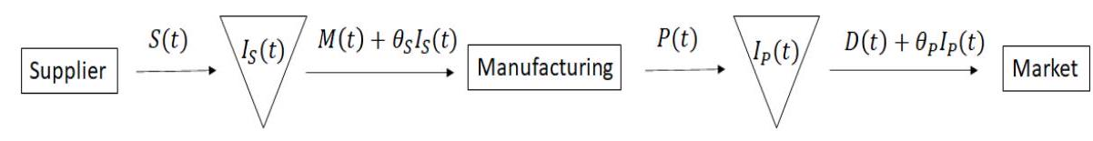
Figure 1: Supply chain coordination
The stocks are reviewed continuously. Denote the firm's planning horizon by $[0,T]$. The inventory levels in each stock, during the planning horizon at time $t$, are denoted by $I_{S}(t)$ and $I_{P}(t)$, respectively. In terms of optimal control, $I_{S}(t)$ and $I_{P}(t)$ are state variables. At any time $t$, the control variables are the raw material supply rate $S(t)$, the raw material transfer rate $M(t)$, and the finished goods production rate $P(t)$. The variations of the first stock are governed by the following state equation:
$\frac{dI_{S}(t)}{dt}=S\left(t\right)-M\left(t\right)-θ_{S}I_{S}\left(t\right), I_{S}\left(0\right)=I_{S}^{0}$ (2.1)
where $I_{S}(0)$ is the initial inventory level of raw material, and $θ_{S}(t)$ is their deterioration rate. The variations of the second sock are governed by the following state equation:
$\frac{dI_{P}(t)}{dt}=P(t)-D(t)-θ_{P}I_{P}(t), I_{P}(0)=I_{P}^{0}.$ (2.2)
where $I_{P}(0)$ is the initial inventory level of finished goods, $θ_{S}(t)$ is their deterioration rate, and $D(t)$ is the dynamic demand rate at time $t.$
We assume that the model is of the tracking type. Targets are assigned to each state and control variable and the firm seeks to minimize the gap $Δf(t)$ between each variable $f(t)$ and its target $\overset{ˆ}{f}(t)$. Denoting for $i=1,2$ by $q_{i},r_{i}$, and $c_{i}$ the penalties associated with the deviations, the objective function to minimize is
$J=\frac{1}{2}\int_{0}^{T}{ }\left[∥x(t)∥_{Q}^{2}+∥u(t)∥_{R}^{2}\right]dt+\frac{1}{2}∥x(T)∥_{C}^{2},$ (2.3)
where the state and control vectors are given by
$$x(t)=\left[\begin{matrix}ΔI_{S}(t) \\ ΔI_{P}(t)\end{matrix}\right], u(t)=\left[\begin{matrix}ΔS(t) \\ ΔM(t) \\ ΔP(t)\end{matrix}\right], x^{0}=\left[\begin{matrix}ΔI_{S}(0) \\ ΔI_{P}(0)\end{matrix}\right],$$
and
$$Q=\left[\begin{matrix}q_{1} & 0 \\ 0 & q_{2}\end{matrix}\right], R=\left[\begin{matrix}r_{1} & 0 & 0 \\ 0 & r_{2} & 0 \\ 0 & 0 & r_{3}\end{matrix}\right], C=\left[\begin{matrix}c_{1} & 0 \\ 0 & c_{2}\end{matrix}\right]$$
The variations of the state variables are rewritten in matrix notation as
$\frac{dx(t)}{dt}=Ax(t)+Bu(t), x(0)=x^{0},$
$\frac{dx(t)}{dt}=Ax(t)+Bu(t), x(0)=x^{0},$ (2.4)
where
$$A=\left[\begin{matrix}-θ_{S} & 0 \\ 0 & -θ_{P}\end{matrix}\right], B=\left[\begin{matrix}1 & -1 & 0 \\ 0 & 0 & 1\end{matrix}\right]$$
Introduce the Hamiltonian
$$H=-\frac{1}{2}\left[∥x(t)∥_{Q}^{2}+∥u(t)∥_{R}^{2}\right]+Λ(t)^{⊤}[Ax(t)+Bu(t)]$$
where $Λ(t)={\left[\begin{matrix}λ_{1}(t) & λ_{2}(t)\end{matrix}\right]}^{⊤}$ is the co-state vector. The necessary optimality conditions
$$H_{u(t)}=0, H_{x(t)}=-\frac{d}{dt}Λ(t),$$
are equivalent to the differential system
$$\frac{d}{dt}Z(t)=ΦZ(t)$$
where $Z(t)={\left[\begin{matrix}x(t) & Λ(t)\end{matrix}\right]}^{⊤}$ and $Φ=\left[\begin{matrix}A & BR^{-1}B^{⊤} \\ Q & -A^{⊤}\end{matrix}\right]$. The solution of this differential system has the following form
$$Z(t)=φ(t)Z(0).$$
The matrix $φ(t)$ can be found from
$$φ(t)=\sum_{i=1}^{4}{ }V(:,i)W(i,:)e^{m_{i}t}$$
where $m_{i},i=1,⋯,4$ denote the eigenvalues of the matrix $Φ$ and are given by
$m_{1}=\sqrt{\frac{r_{3}θ_{P}^{2}+q_{2}}{r_{3}}}, { m}_{2}=\sqrt{\frac{r_{1}r_{2}θ_{S}^{2}+q_{1}r_{1}+q_{1}r_{2}}{r_{1}r_{2}}}, { m}_{3}=-m_{1}, { m}_{4}=-m_{2}$.
Also, $V$ denotes the matrix whose columns are the corresponding eigenvectors and is given by
$$V=\left[\begin{matrix}0 & v_{2} & 0 & v_{4} \\ v_{1} & 0 & v_{3} & 0 \\ 0 & 1 & 0 & 1 \\ 1 & 0 & 1 & 0\end{matrix}\right]$$
where
$$\begin{matrix} & v_{1}=\frac{1}{q_{2}}\left[\sqrt{\frac{r_{3}θ_{P}^{2}+q_{2}}{r_{3}}}-θ_{P}\right], v_{2}=\frac{1}{q_{1}}\left[\sqrt{\frac{r_{1}r_{2}θ_{S}^{2}+q_{1}r_{1}+q_{1}r_{2}}{r_{1}r_{2}}}-θ_{S}\right], \\ & v_{3}=-\frac{1}{q_{2}}\left[\sqrt{\frac{r_{3}θ_{P}^{2}+q_{2}}{r_{3}}}+θ_{P}\right], v_{4}=-\frac{1}{q_{1}}\left[\sqrt{\frac{r_{1}r_{2}θ_{S}^{2}+q_{1}r_{1}+q_{1}r_{2}}{r_{1}r_{2}}}+θ_{S}\right].\end{matrix}$$
The matrix $W$ is the inverse of the matrix $V$ and is given by
$$W=\left[\begin{matrix}0 & w_{3} & 0 & w_{7} \\ w_{1} & 0 & w_{5} & 0 \\ 0 & w_{4} & 0 & w_{8} \\ w_{2} & 0 & w_{6} & 0\end{matrix}\right]$$
where
$$\begin{matrix} & w_{1}=q_{1}\sqrt{\frac{r_{1}r_{2}}{2\left(r_{1}r_{2}θ_{S}^{2}+q_{1}r_{1}+q_{1}r_{2}\right)}}, w_{2}=-w_{1} \\ & w_{3}=q_{2}\sqrt{\frac{r_{3}}{2\left(r_{3}θ_{P}^{2}+q_{2}\right)}}, w_{4}=-w_{3} \\ & w_{5}=\frac{\sqrt{r_{1}r_{2}θ_{S}^{2}+q_{1}r_{1}+q_{1}r_{2}}+\sqrt{r_{1}r_{2}}θ_{S}}{\sqrt{2\left(r_{1}r_{2}θ_{S}^{2}+q_{1}r_{1}+q_{1}r_{2}\right)}}, w_{6}=\frac{\sqrt{r_{1}r_{2}θ_{S}^{2}+q_{1}r_{1}+q_{1}r_{2}}-\sqrt{r_{1}r_{2}}θ_{S}}{\sqrt{2\left(r_{1}r_{2}θ_{S}^{2}+q_{1}r_{1}+q_{1}r_{2}\right)}} \\ & w_{7}=\frac{\sqrt{r_{3}}θ_{P}+\sqrt{r_{3}θ_{P}^{2}+q_{2}}}{\sqrt{2\left(r_{3}θ_{P}^{2}+q_{2}\right)}}, w_{8}=-\frac{\sqrt{r_{3}}θ_{P}-\sqrt{r_{3}θ_{P}^{2}+q_{2}}}{\sqrt{2\left(r_{3}θ_{P}^{2}+q_{2}\right)}}.\end{matrix}$$
The matrix $φ(t)$ is partitioned into 4 submatrices as follows:
$$φ(t)=\left[\begin{matrix}φ_{1}(t) & ∣ & φ_{2}(t) \\ - & - & - \\ φ_{3}(t) & ∣ & φ_{4}(t)\end{matrix}\right],$$
where
$$\begin{matrix} & φ_{1}(t)=\left[\begin{matrix}φ_{11}(t) & 0 \\ 0 & φ_{22}(t)\end{matrix}\right], φ_{3}(t)=\left[\begin{matrix}φ_{13}(t) & 0 \\ 0 & φ_{24}(t)\end{matrix}\right] \\ & φ_{2}(t)=\left[\begin{matrix}φ_{31}(t) & 0 \\ 0 & φ_{42}(t)\end{matrix}\right], φ_{4}(t)=\left[\begin{matrix}φ_{33}(t) & 0 \\ 0 & φ_{44}(t)\end{matrix}\right]\end{matrix}$$
with
$$\begin{matrix} & φ_{11}(t)=v_{2}w_{1}e^{m_{2}t}+v_{4}w_{2}e^{m_{4}t}, φ_{13}(t)=v_{2}w_{5}e^{m_{2}t}+v_{4}w_{5}e^{m_{4}t} \\ & φ_{22}(t)=v_{1}w_{3}e^{m_{1}t}+v_{3}w_{4}e^{m_{3}t}, φ_{24}(t)=v_{1}w_{7}e^{m_{1}t}+v_{3}w_{8}e^{m_{3}t} \\ & φ_{31}\left(t\right)=w_{1}e^{m_{2}t}+w_{2}e^{m_{4}t}, φ_{33}(t)=w_{5}e^{m_{2}t}+w_{6}e^{m_{4}t} \\ & φ_{42}\left(t\right)=w_{3}e^{m_{1}t}+w_{4}e^{m_{3}t}, φ_{44}(t)=w_{7}e^{m_{1}t}+w_{8}e^{m_{3}t}\end{matrix}$$
To determine $Z(0)={\left[\begin{matrix}x(0) & Λ(0)\end{matrix}\right]}^{⊤}$, we note that $x(0)$ is given, while $Λ(0)$ can be found from the transversality condition $Λ(T)=Cx(T)$. We find
$$Λ(0)={\left[Cφ_{2}(T)-φ_{4}(T)\right]}^{-1}\left[φ_{3}(T)-Cφ_{1}(T)\right]x(0).$$
Carrying out the calculations, we find the optimal state variables:
$$\left\{\begin{matrix}ΔI_{S}(t) & =\left[φ_{11}(t)+\frac{φ_{13}(T)-c_{1}φ_{11}(T)}{c_{1}φ_{31}(T)-φ_{33}(T)}φ_{31}(t)\right]x_{1}(0), \\ ΔI_{P}(t) & =\left[φ_{22}(t)+\frac{φ_{24}(T)-c_{2}φ_{22}(T)}{c_{2}φ_{42}(T)-φ_{44}(T)}φ_{42}(t)\right]x_{2}(0),\end{matrix}\right.$$
the optimal co-state variables:
$$\left\{\begin{matrix}λ_{1}(t)=\left[φ_{13}(t)+\frac{φ_{13}(T)-c_{1}φ_{11}(T)}{c_{1}φ_{31}(T)-φ_{33}(T)}φ_{33}(t)\right]x_{1}(0) \\ λ_{2}(t)=\left[φ_{24}(t)+\frac{φ_{24}(T)-c_{2}φ_{22}(T)}{c_{2}φ_{42}(T)-φ_{44}(T)}φ_{44}(t)\right]x_{2}(0)\end{matrix}\right.$$
and the optimal control variables:
$$\left\{\begin{matrix}ΔS(t) & =\frac{1}{r_{1}}\left[φ_{13}(t)+\frac{φ_{13}(T)-c_{1}φ_{11}(T)}{c_{1}φ_{31}(T)-φ_{33}(T)}φ_{33}(t)\right]x_{1}(0) \\ ΔC(t) & =\frac{1}{r_{2}}\left[φ_{13}(t)+\frac{φ_{13}(T)-c_{1}φ_{11}(T)}{c_{1}φ_{31}(T)-φ_{33}(T)}φ_{33}(t)\right]x_{1}(0), \\ ΔP(t) & =\frac{1}{r_{3}}\left[φ_{24}(t)+\frac{φ_{24}(T)-c_{2}φ_{22}(T)}{c_{2}φ_{42}(T)-φ_{44}(T)}φ_{44}(t)\right]x_{2}(0).\end{matrix}\right.$$
Numerical Example. Consider a manufacturing firm, at time $t=0$, it wants to determine the optimal raw material supply rate $S(t)$, the optimal raw material transfer rate $M(t)$, and the finished goods production rate $P(t)$ for the next year (12 months). Assume the data are as shown in Table 1. Implementing the results of this section has all the deviations tend to zero as shown in Figure 2. This means that each state variable and each control variable tend to its goal by the end of the planning horizon, as desired. The cost of this strategy is found to be $J=199.92$.
Table 1: Data for numerical example
Parameter | Value
Length of planning horizon | $$T=12$$
Penalties | $$q_{1}=3,q_{2}=2,r_{1}=5,r_{2}=7,r_{3}=10,c_{1}=10,c_{2}=20$$
Deterioration rates | $$θ_{S}=0.01,θ_{P}=0.02$$
Initial inventory levels | $$x(0)={\left[ΔI_{S}^{0}=10,ΔI_{P}^{0}=5\right]}^{⊤}$$

A sensitivity analysis on some of the parameters brings insight into the performance of the system. Keeping the base values as in Table 1 we varied the length of the planning horizon to obtain the graph in Figure 3. Initially the cost is very high at 1223. However, very fast it decreases by the first month to remain fairly constant at 199.92. This means that the method does not work well for the very short term and should be used for medium to long term.

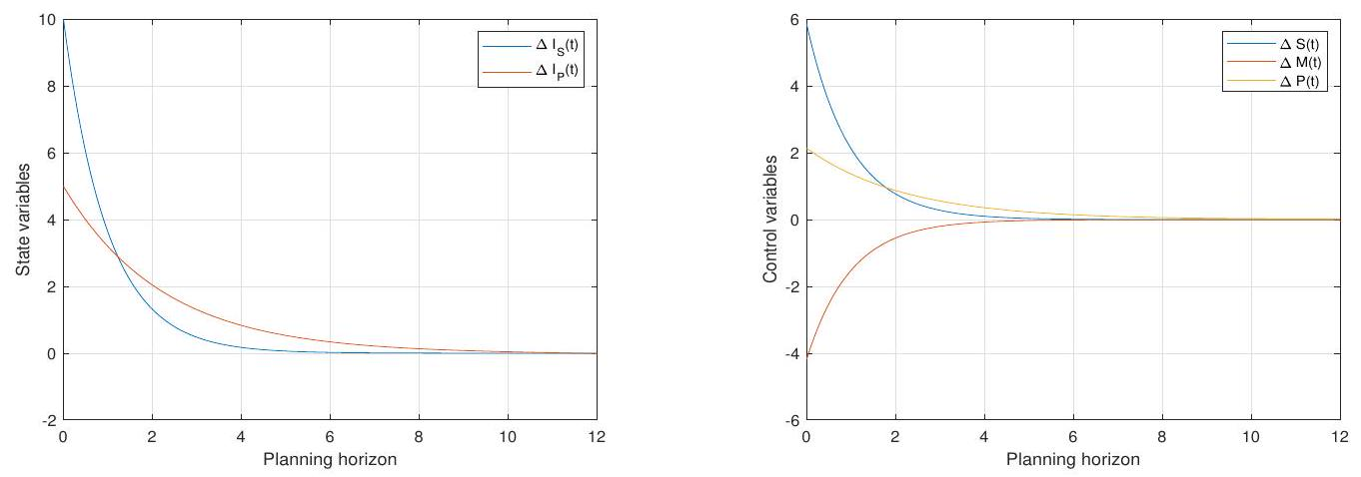
Figure 2: Optimal state variables (left) and control variables (right)
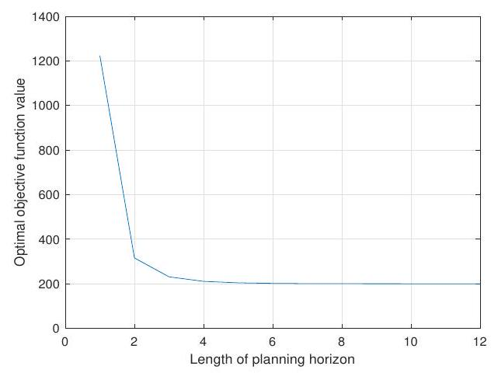
Figure 3: Sensitivity to length of planning horizon
Another analysis was to explore the effect of the deterioration rates on the optimal objective function value. Varying these parameters from $0.1$ to $0.9$ by increments of $0.1$ resulted in Figure 4 (left). We note that as the deterioration rate of the raw material, or the deterioration of the finished product on the shelves, or both increase, the objective function decreases.
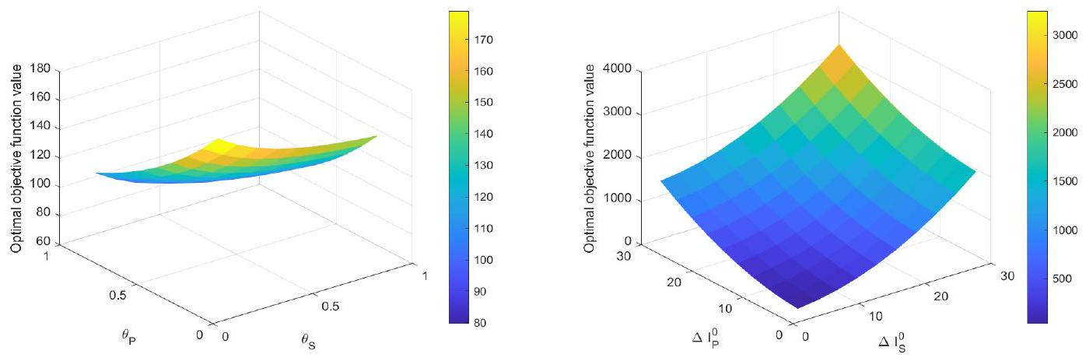
Figure 4: Sensitivity to deterioration rates (left) and initial conditions (right)
The maximum value of the objective function is $178.8$ when $θ_{S}=θ_{P}=0.1$ and the minimum value is $79.61$ when $θ_{S}=θ_{P}=0.9$. The reason for this behaviour is that when the material or the product deteriorate faster, the different variables have to reach their goals faster to mitigate the losses. The gaps are reduced faster and this, in turn, leads to a lower cost.
Finally, we evaluated the effect of the initial conditions on the optimal objective function value. The initial gaps $ΔI_{S}^{0}$ and $ΔI_{P}^{0}$ were varied from 3 to 30 by increments of 3 and the results are depicted in Figure 4 (right). We observe that the optimal objective function value increases as either $ΔI_{S}^{0}$ or $ΔI_{P}^{0}$ or both increase. The maximum value of the objective function is 3243 when $ΔI_{S}^{0}=ΔI_{P}^{0}=30$ and the minimum value of the objective function is $32.43$ when $ΔI_{S}^{0}=ΔI_{P}^{0}=3$. The reason for this is that when the initial gaps are small, the variables reach their goals right away. And as the gaps grow wider, it takes more time for the variables to reach their goals, which increases cost.

Periodic-Review Model
We consider in this section the same model as in the previous one. However, we assume now that the stocks are reviewed periodically instead of continuously. We also use the same notation, with the difference that the variables are now observed at the end of a period $k$ instead of at any time $t$. Let $N>0$ represent the number of periods in the planning horizon $[0,H]$. Then, for $k=0,⋯,N-1$, equations equivalent to (2.1)-(2.2) are used to describe the variations of the inventory levels in the stocks as follows:
$I_{S}(k+1)=S(k)-M(k)+\left(1-θ_{S}\right)I_{S}(k), I_{S}(0)=I_{S}^{0}$ (3.1)
and
$I_{P}(k+1)=P(k)-D(k)+\left(1-θ_{P}\right)I_{P}(k), I_{P}(0)=I_{P}^{0}.$
$I_{P}(k+1)=P(k)-D(k)+\left(1-θ_{P}\right)I_{P}(k), I_{P}(0)=I_{P}^{0}.$ (3.2)
Let the state and control vectors be given by
$$x(k)=\left[\begin{matrix}ΔI_{S}(k) \\ ΔI_{P}(k)\end{matrix}\right], u(k)=\left[\begin{matrix}ΔS(k) \\ ΔM(k) \\ ΔP(k)\end{matrix}\right], x(0)=\left[\begin{matrix}ΔI_{S}(0) \\ ΔI_{P}(k)\end{matrix}\right]$$
As in the continuous-review case, the model can be written in matrix form
$\min{J=\frac{1}{2}\sum_{k=0}^{N}{ }\left[∥x(k)∥_{Q}^{2}+∥u(k)∥_{R}^{2}\right]+\frac{1}{2}∥x(N+1)∥_{C}^{2},}$
$\min{J=\frac{1}{2}\sum_{k=0}^{N}{ }\left[∥x(k)∥_{Q}^{2}+∥u(k)∥_{R}^{2}\right]+\frac{1}{2}∥x(N+1)∥_{C}^{2},}$ (3.3)
subject to
$x(k+1)=Ax(k)+Bu(k), x(0)=x^{0}-{\overset{ˆ}{I}}_{S}^{0},$ (3.4)
where
$$Q=\left[\begin{matrix}q_{1} & 0 \\ 0 & q_{2}\end{matrix}\right], R=\left[\begin{matrix}r_{1} & 0 & 0 \\ 0 & r_{2} & 0 \\ 0 & 0 & r_{3}\end{matrix}\right], C=\left[\begin{matrix}c_{1} & 0 \\ 0 & c_{2}\end{matrix}\right]$$
and
$$A=\left[\begin{matrix}1-θ_{S} & 0 \\ 0 & 1-θ_{P}\end{matrix}\right], B=\left[\begin{matrix}1 & -1 & 0 \\ 0 & 0 & 1\end{matrix}\right]$$
Introduce the Lagrangian
$\begin{matrix}L(u,x,λ,k)= & \frac{1}{2}∥x(N+1)∥_{C}^{2}+\sum_{k=0}^{N}{ } \frac{1}{2}\left[∥x(k)∥_{Q}^{2}+∥u(k)∥_{R}^{2}\right] \\ & +Λ(k+1)^{T}[-x(k+1)+Ax(k)+Bu(k)]. \end{matrix}$ (3.5)
where $Λ(k)={\left[\begin{matrix}λ_{1}(k) & λ_{2}(k)\end{matrix}\right]}^{⊤}$ is the vector of Lagrange multipliers. The necessary optimality conditions
$\frac{∂L(u,x,Λ,k)}{∂u(k)}=0, \frac{∂L(u,x,Λ,k)}{∂x(k)}=0,$ (3.6)
yield the discrete Ricatti equation:
$S(k)=Q+A^{T}S(k+1)A-A^{T}S(k+1)BV(k+1).$ (3.7)

where the diagonal matrix $S(k)$ has all positive entries and the matrix $V(k)$ is given by
$V(k+1)=R^{-1}{\left[1+R^{-1}B^{T}S(k+1)B\right]}^{-1}B^{T}S(k+1)A.$ (3.8)
Here 1 denotes the $3×3$ identity matrix. The Riccati equation is solved backwards using the final condition
$S(N+1)=C.$ (3.9)
Carrying out the calculations, we find the optimal state variables:
$x(k+1)=[A-BV(k+1)]x(k),$ (3.10)
or
$x(k)=\prod_{i=1}^{k}{ }[A-BV(i)]x(0).$ (3.11)
and the optimal control vector:
$u(k)=-V(k+1)\prod_{i=1}^{k}{ }[A-BV(i)]x(0)$ (3.12)
Numerical Example. Consider the same data as in the previous example (see Table 1), except for the length of the planning horizon that is replaced by the number of periods $N=12$. Implementing the results of this section, we observe in Figure 5 that all the deviations between the variables and their corresponding goal tend to zero as desired. The cost of this strategy is found to be $J=621.91$. This already shows that the periodic-review policy is much more expensive than the continuous-review policy, a relative difference of $\frac{621.91-199.92}{199.92}=211.08\%$. A sensitivity analysis similar to the one in the previous example is carried out. We start with the number of periods $N$ and we see in Figure 6 that as $N$ increases, the objective function value drops sharply from a high value of $667.57$ for small values of $N$ to reach $622.87$ by the fifth period to become fairly constant.

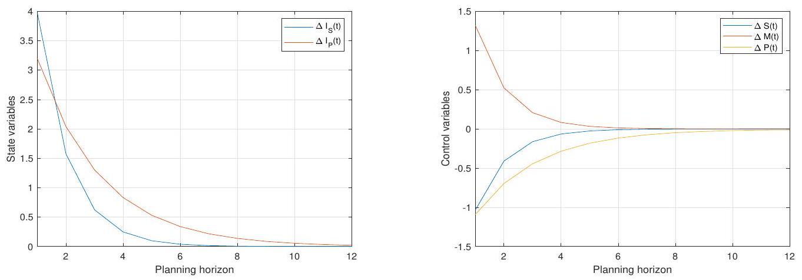
Figure 5: Optimal state variables (left) and control variables (right)
This confirms the conclusion that the method is more suitable for medium to long term range.
Exploring the effect of the deterioration rate confirms the observation that as the raw material deterioration rate, or the finished product deterioration rate, or both increase, the optimal objective function value decreases, see Figure 7 (left). The maximum value of the objective function is $562.4$ when $θ_{S}=θ_{P}=0.1$ and the minimum value of the objective function is $351.9$ when $θ_{S}=θ_{P}=0.9$.
Finally, we confirmed in Figure 7 (right) the effect of the initial conditions on the optimal objective function value. As the initial gaps $ΔI_{S}^{0}$ or $ΔI_{P}^{0}$ or both increase, the optimal objective function value increases The maximum value of the objective function is 9206 when $ΔI_{S}^{0}=ΔI_{P}^{0}=30$ and the minimum value of the objective function is $92.06$ when $ΔI_{S}^{0}=ΔI_{P}^{0}=3$.
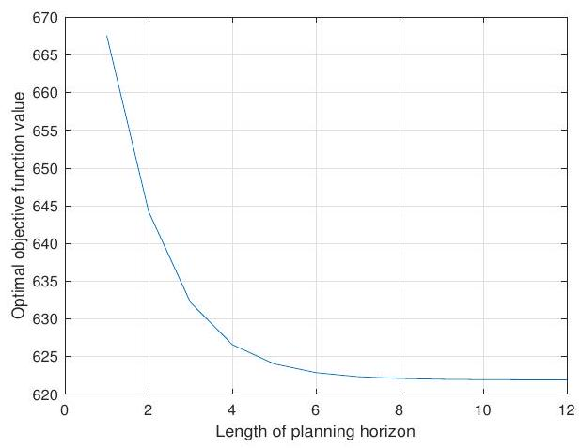
Figure 6: Sensitivity to length of planning horizon
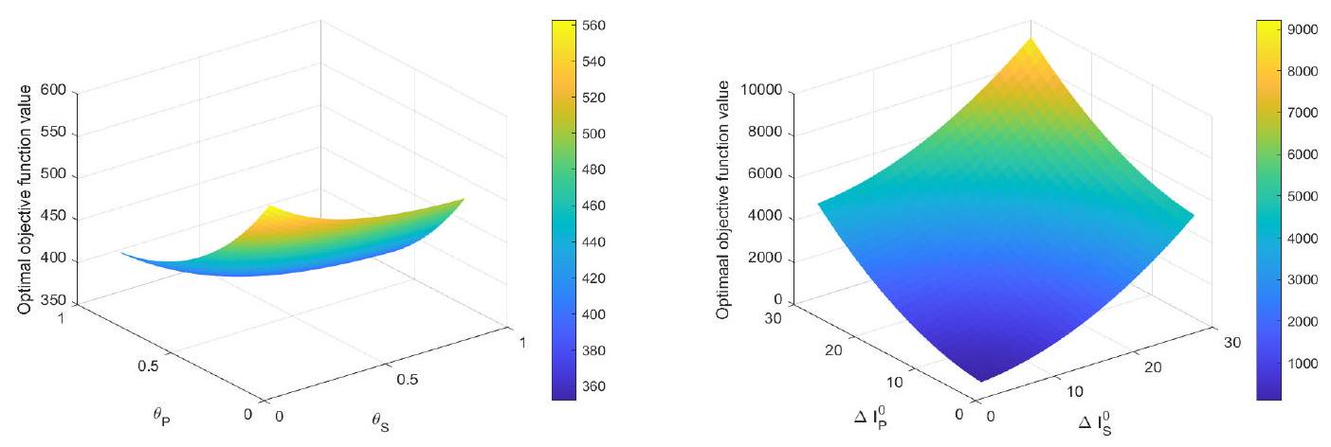
Figure 7: Sensitivity to deterioration rates (left) and initial conditions (right)

- Conclusion
We have considered in this paper an integrated model for the coordination of the activities of a supply chain where the control variables are the optimal raw material supply rate, the optimal transfer rate of the raw material for production, and the optimal production rate. Optimal control theory can be used to obtain these variables when the planning horizon is of medium to long range. Other insights gained are that the method applied works well when raw material and end product deterioration are high. Finally, best results are obtained when the initial gaps between the inventory levels and their respective goals are the smallest.
This model can be generalized in many ways. For example, one can consider the case of multiple products or multiple suppliers. Another possibility would be the inclusion of returned products from the market. Remanufactured products can be either as good-as-old or as-good-as new. The case of stochastic demand and/or stochastic return rate may also be worth investigating.

References
[1] Anggrahini, D., Kurniati, N., and Sukma, A.P. (2021). Data analytics for transforming towards smart supplier relationship management: A case study in manufacturing company, Proceedings of the International Conference on Industrial Engineering and Operations Management, Sao Paulo, Brazil.
[2] Autry, C.W. and Golicic, S.L. (2010). Evaluating buyer-supplier relationship-performance spirals: A longitudinal study, Journal of Operations Management, Vol. 28, 87-100.
[3] Choy, K.L., Lee, W.B., and Lo, B. (2002). Development of a case based intelligent customer-supplier relationship management system, Expert Systems with Applications, Vol, 23, No.3, 281-297.
[4] Choy, K.L., Lee, W.B., and Lo, B. (2003). Design of an intelligent supplier relationship management system: a hybrid case based neural network approach, Expert Systems with Applications, Vol. 24, 225-237.
[5] Corsten, D. and Felde, J., (2005). Exploring the performance effects of key-supplier collaboration: An empirical investigation into Swiss buyer-supplier relationships, International Journal of Physical Distribution & Logistics Management, Vol. 35, No. 6, 445-461.
[6] Cox, A., Lonsdale, C., Sanderson, J., and Watson, G. (2004) Cases in misaligned and sub-optimal buyer and supplier relationship management. In: Business Relationships for Competitive Advantage, Chapter 6, 163192, Palgrave Macmillan, London.
[7] Forkmann, S., Henneberg, S.C., Naudé, P., and Mitrega, M. (2016). Supplier relationship management capability: a qualification and extension, Industrial Marketing Management, Vol. 57, 185-200.
[8] Hallikas, J., Puumalainen, K., Vesterinen, T., and Virolainen, V.M. (2005). Risk-based classification of supplier relationships, Journal of Purchasing & Supply Management, Vol. 11, 72-82.
[9] Kappelman, A.C. and Sinha, A.K. (2021). Optimal control in dynamic food supply chains using big data, Computers and Operations Research, Vol. 126, 105117.
[10] Lambert, D.M. and Schwieterman, M.A., (2012). Supplier relationship management as a macro business process, Supply Chain Management: An International Journal, Vol. 17, No. 3, 337-352.
[11] Laumanns, M. and Lefeber, E. (2006). Robust optimal control of material flows in demand-driven supply networks, Physica A, Vol. 363, 24-31.
[12] Lee, Y.C.E. (2007) Coordinated Supply Chain management and Optimal Control Problems, PhD Thesis, Department of Applied Mathematics, The Hong Kong Polytechnic University.
[13] Leppelt, T., Foerstl, K., Reuter, C., and Hartmann, E. (2013). Sustainability management beyond organizational-boundaries sustainable supplier relationship management in the chemical industry, Journal of Cleaner Production, Vol. 56, 94-102.
[14] Lindgren, O. and Bernhardsson, V. (2018). Optimal Supplier Relationship Management: A multiple case study of Swedish MNE within the engineered products industry, Master Thesis, Division of Engineering Logistics, Lund University, Lund, Sweden.
[15] Liu, Y., Luo, Y., and Liu, T. (2009). Governing buyer-supplier relationships through transactional and relational mechanisms: Evidence from China, Journal of Operations Management, Vol. 27, 294-309.
[16] Mahama, H. (2006). Management control systems, cooperation and performance in strategic supply relationships: A survey in the mines, Management Accounting Research, Vol. 17, 315-339.
[17] Mettler, T. and Rohner, P. (2009). Supplier relationship management: A case study in the context of health care, Journal of Theoretical and Applied Electronic Commerce Research, Vol. 4, No. 3, 58-71.
[18] Mitrega, M., Forkmann, S., Zaefarian, G., and Henneberg, S.C. (2017). Networking capability in supplier relationships and its impact on product innovation and firm performance, International Journal of Operations & Production Management, Vol. 37, No. 5, 577-606.
[19] Nair, A., Narasimhan, R., and Bendoly, E. (2011). Coopetitive Buyer-supplier relationship: An investigation of bargaining power, relational context, and investment strategies, Decision Sciences, Vol. 42, N. 1, 93-127.
[20] Narasimhan, R., Nair, A., Griffith, D.A., Arlbjørn, J.S., and Bendoly, E. (2009). Lock-in situations in supply chains: A social exchange theoretic study of sourcing arrangements in buyer-supplier relationships, Journal of Operations Management, Vol. 27, 374-389.
[21] Obal, M. and Lancioni, R.A. (2013). Maximizing buyer-supplier relationships in the digital era: Concept and research agenda, Industrial Marketing Management, Vol. 42, 851-854.
[22] Oghazi, P., Rad, F.F., Zaefarian, G., Beheshti, H.M.. and Mortazavi, S. (2016). Unity is strength: A study of supplier relationship management integration, Journal of Business Research, Vol. 69, No. 11, 4804-4810.
[23] Ounnar, F., Pujo, P., Mekaouche, L., and Giambiasi, N. (2007). Customers-suppliers relationship management in an intelligent supply chain, Production Planning and Control, Vol. 18, No. 5, 377-387.
[24] Paasi, J., Luoma, T., Valkokari, K. and Lee, N. (2010). Knowledge and intellectual property management in customer-supplier relationships, International Journal of Innovation Management, Vol. 14, No. 4, 629654.
[25] Scuotto, V., Caputo, F., Villasalero, M., and Giudice, M.D. (2017). A multiple buyer-supplier relationship in the A multiple buyer - supplier relationship in the context of SMEs' digital supply chain management, Production Planning & Control, Vol. 28, No . 16, 1378-1388.
[26] Song, D.-P. (2013) Optimal control of basic integrated supply chains, In: Optimal Control and Optimization of Stochastic Supply Chain Systems, chapter 2, 11-35, Springer, London.
[27] Spekman, R.E. and Carraway, R. (2006). Making the transition to collaborative buyer-seller relationships: An emerging framework, Industrial Marketing Management, Vol. 35, 10-19.
[28] Tang, C.S. (1999). Supplier relationship map, International Journal of Logistics: Research and Applications, Vol. 2, No. 1, 39-56
[29] Vanpoucke, E., Vereecke, A., and Boyer, K.K. (2014). Triggers and patterns of integration initiatives in successful buyer-supplier relationships, Journal of Operations Management, Vol. 32, 15-33.
[30] Villena, V.H., Revilla, E., and Choi, T.Y. (2011). The dark side of buyer-supplier relationships: A social capital perspective, Journal of Operations Management, Vol. 29, 561-576.

